**Symmetry Cards**

**Master 8a**

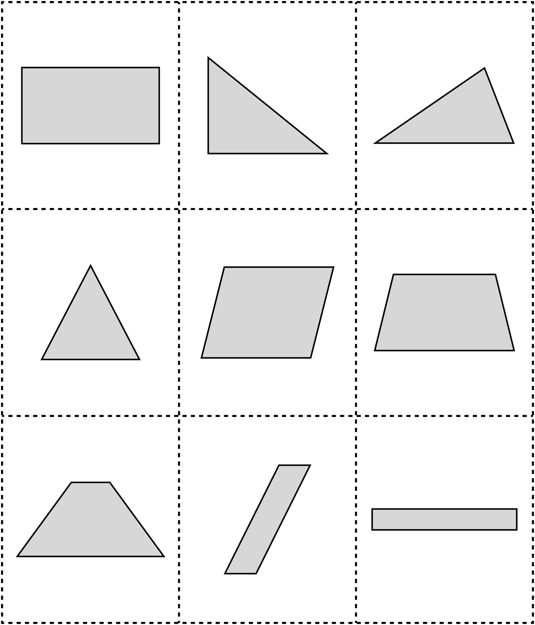

**Symmetry Cards (for Extension)**

**Master 8b**

