Constructing 2-D Shapes Behaviours/Strategies
- Student chooses materials, but struggles to  construct 2-D shapes with given attributes  (e.g., makes an open shape).  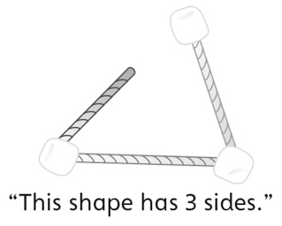 | - Student constructs 2-D shapes with given  attributes, but makes typical shapes  (e.g., equilateral triangle).  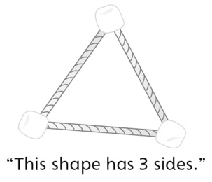 | - Student constructs some 2-D shapes with given  attributes, but struggles when the shape has  more than 4 sides.  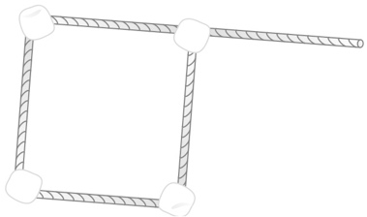
Observations/Documentation
- Student constructs 2-D shapes with given  attributes, but cannot describe how shapes are alike and how they are different.  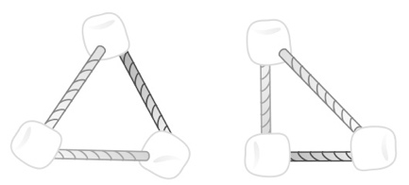 | - Student constructs 2-D shapes with given  attributes, but does not use math language to  describe how shapes are alike and how they are different.  “They both have 3 points. One looks like a  pizza slice and the other doesn’t.” | - Student constructs 2-D shapes with given  attributes and uses math language to describe  how shapes are alike and how they are different.
Observations/Documentation

