**Shape Cards**

**Master 4a**

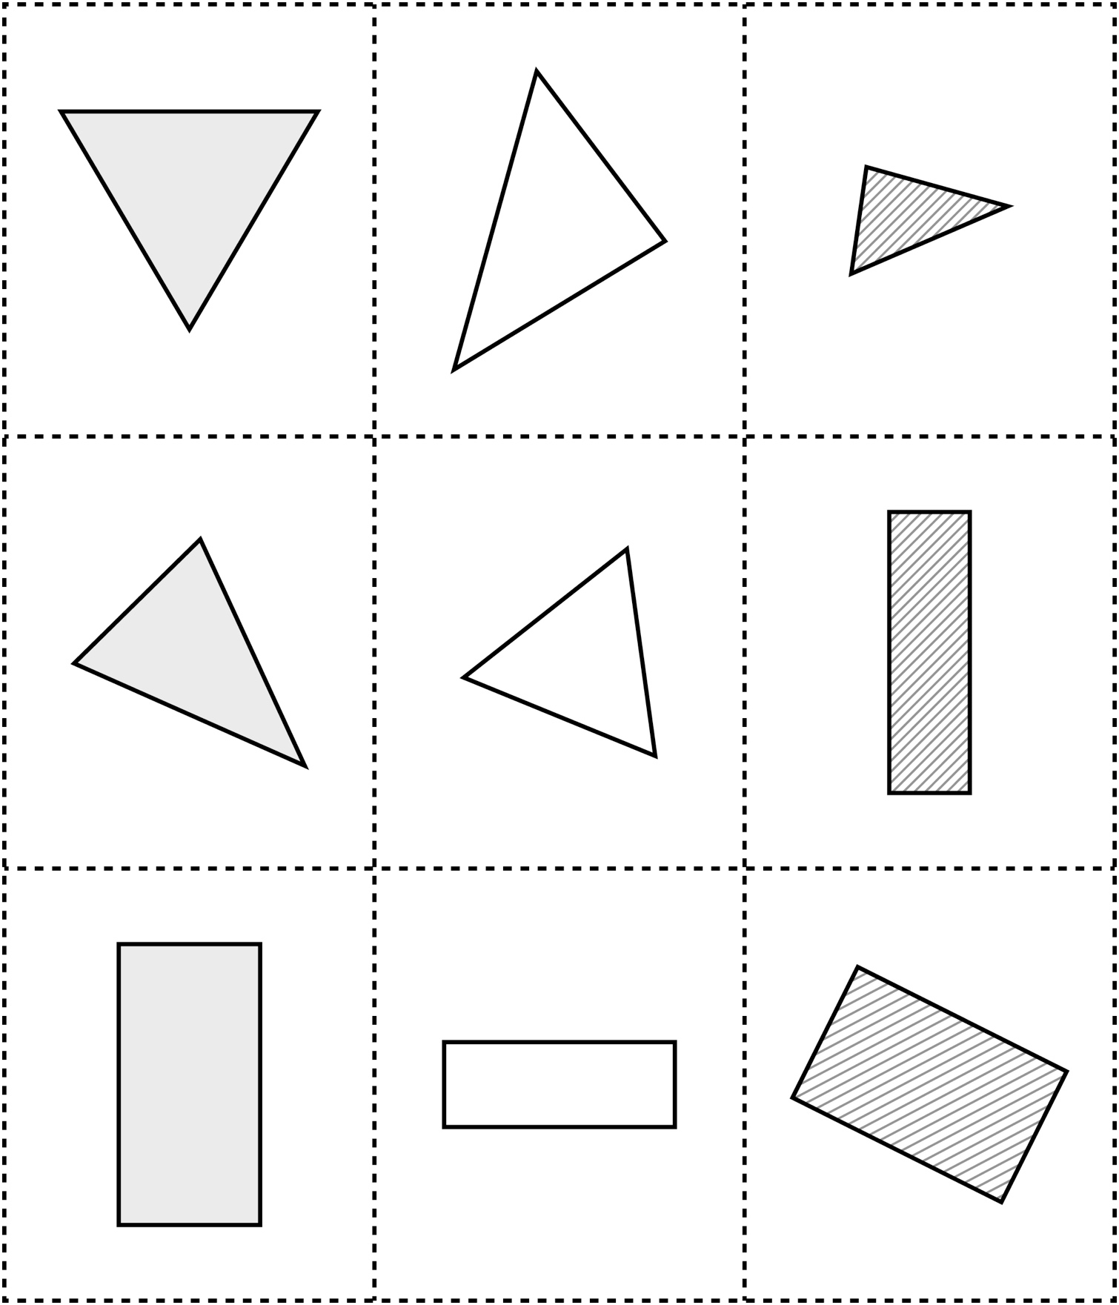

**Shape Cards**

**Master 4b**

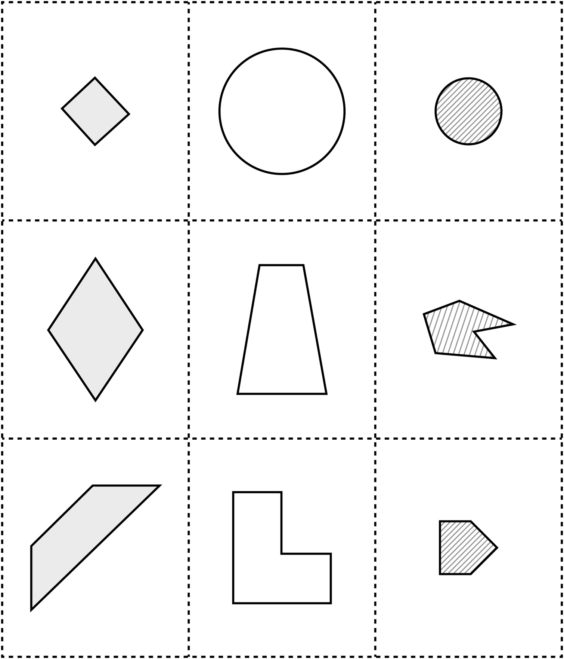

**Shape Cards**

**Master 4c**

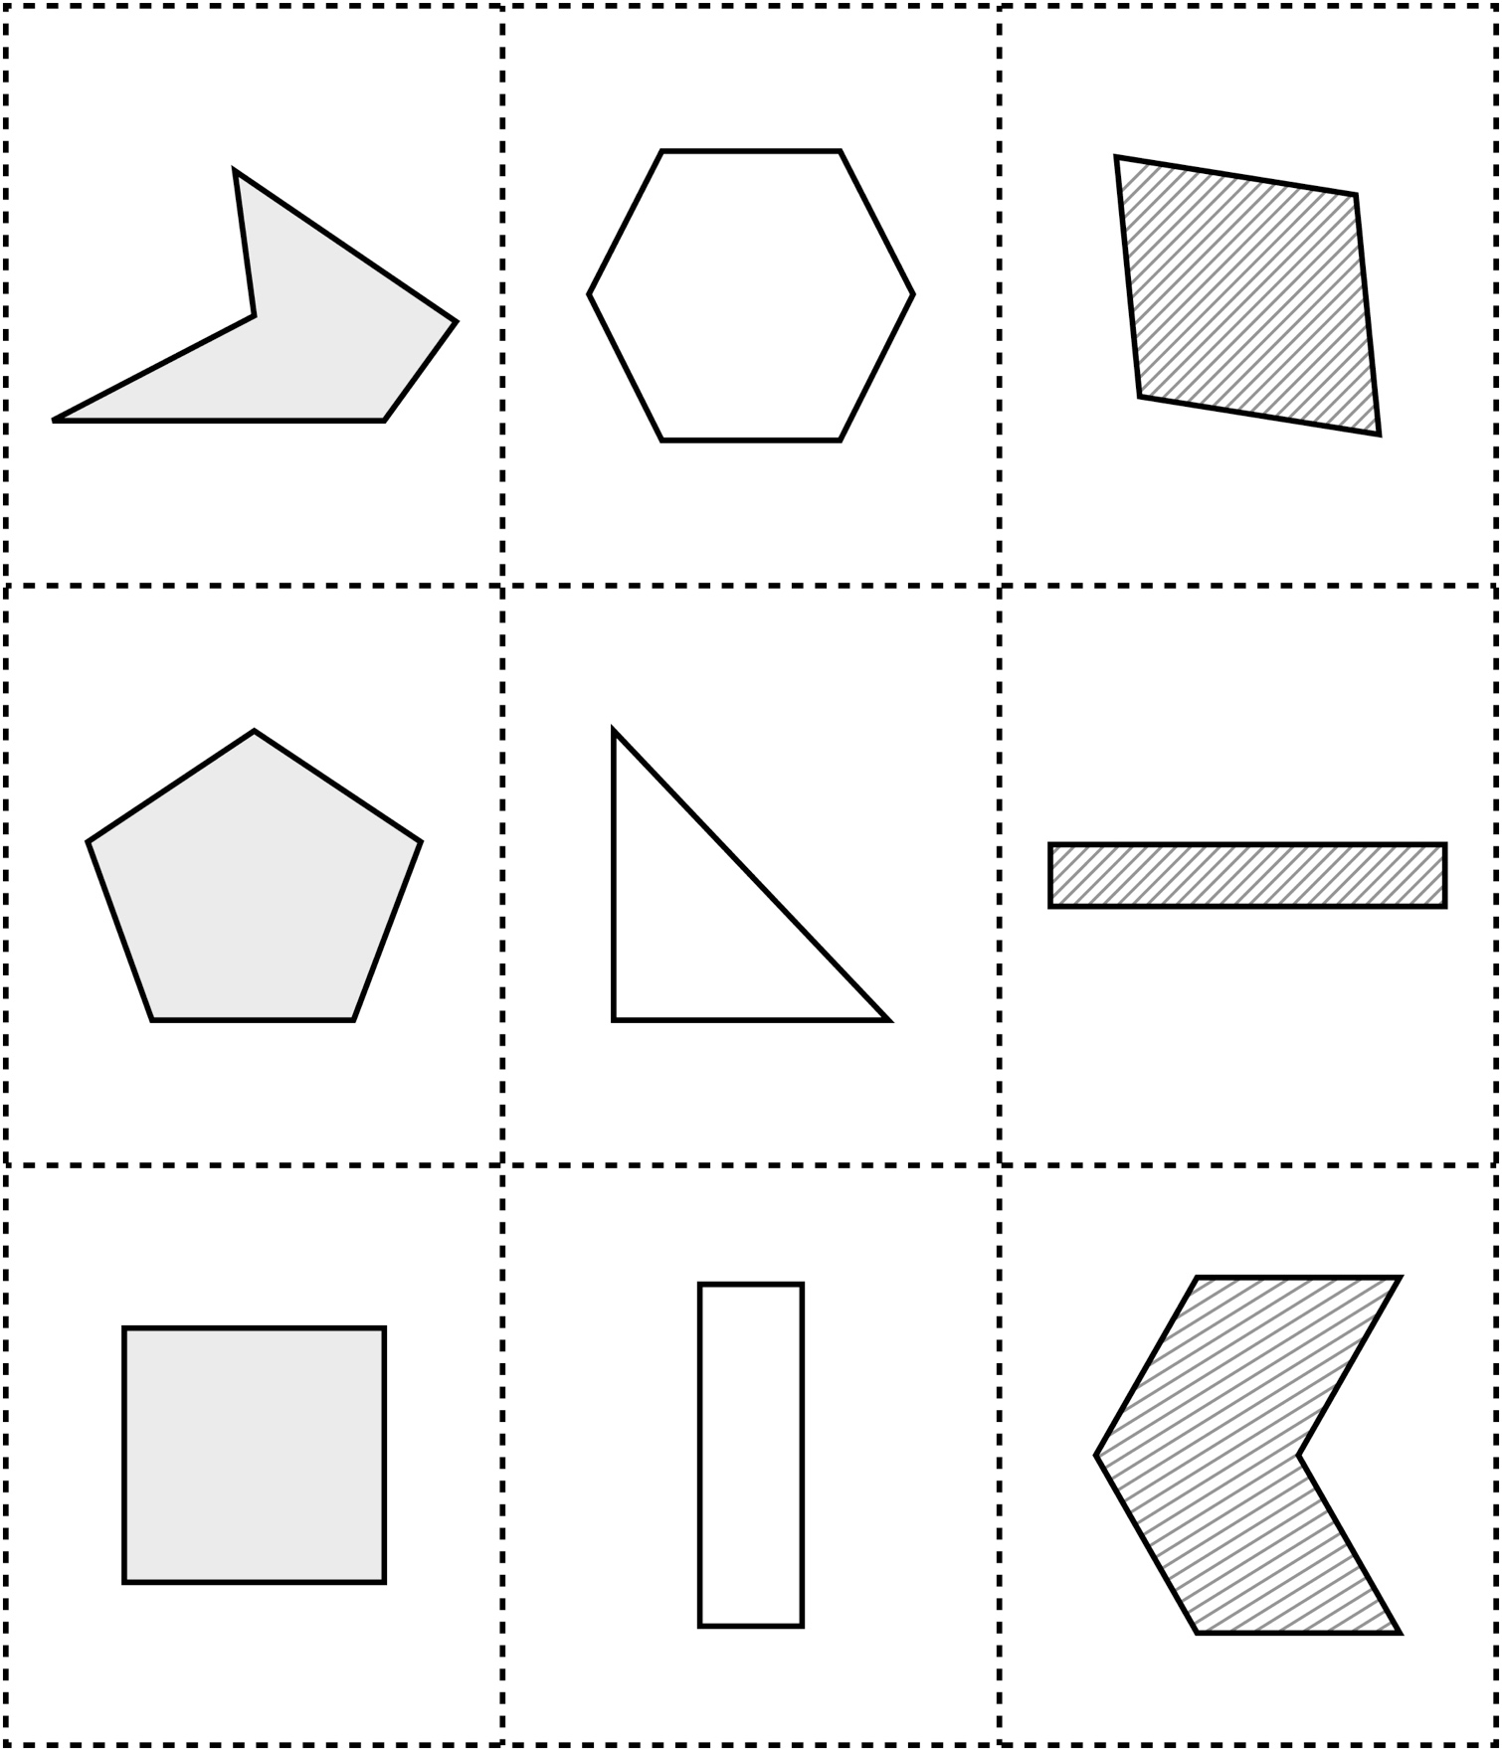

**Shape Cards**

**Master 4d**

