Sorting Shapes Using Two Attributes Behaviours/Strategies
- Student chooses a block, but struggles to  analyze the attributes of the block.  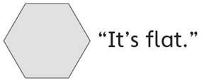 | - Student analyzes the attributes of the blocks,  but is unable to name the shape.  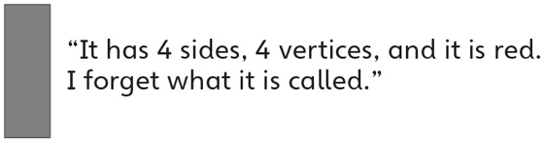 | - Student analyzes the attributes of the blocks,  but is unable to describe how two shapes are  similar/different.  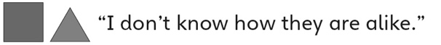
Observations/Documentation
- Student sorts the blocks using a single attribute at a time, but is unable to sort using two attributes simultaneously (ignores overlap).  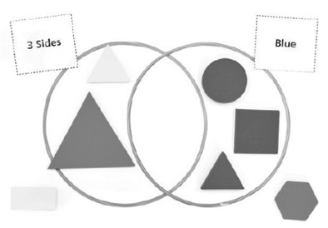 | - Student sorts a set of blocks based on two  attributes, but has difficulty describing the sort.  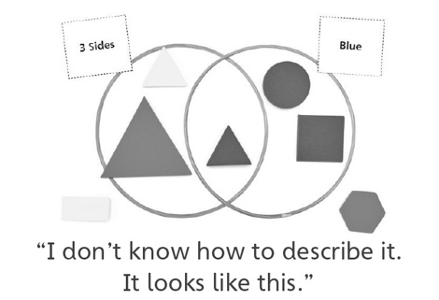 | - Student analyzes geometric attributes of shapes, sorts them using two attributes, and uses mathematical language to describe the sort.  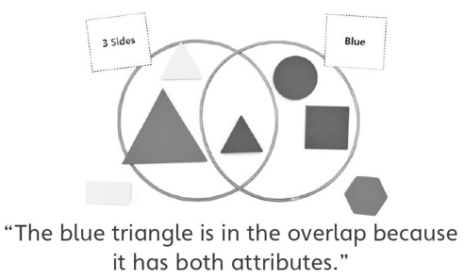
Observations/Documentation

