**Spinner Templates**

**Master 22a**

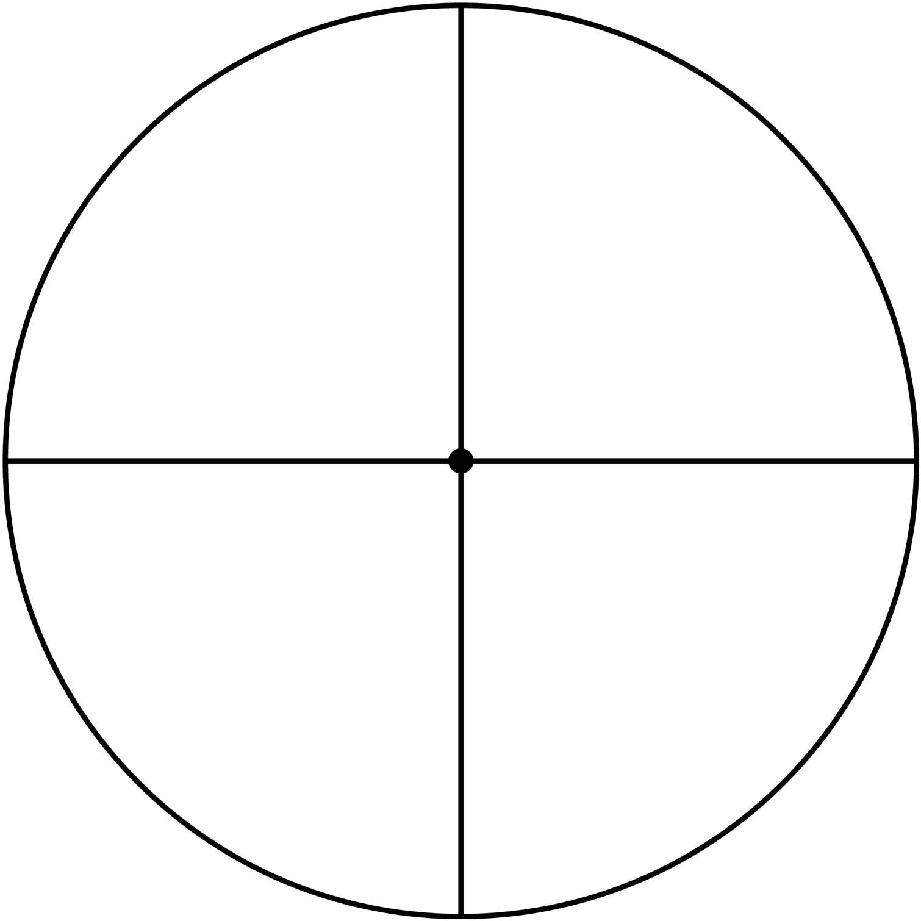

**Spinner Templates**

**Master 22b**

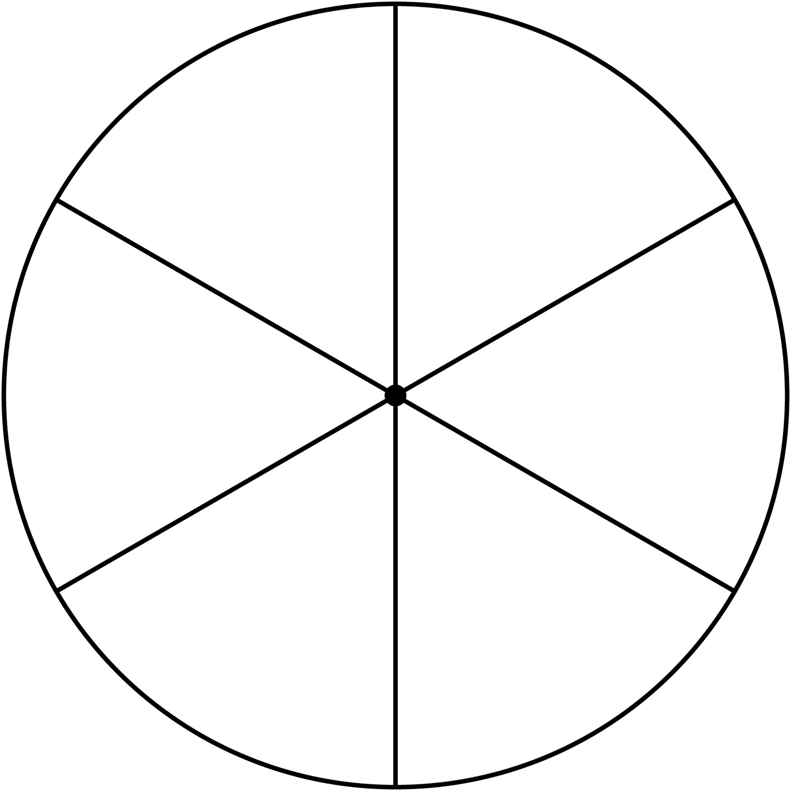

**Spinner Templates**

**Master 22c**

