**Draw the Shape Cards**

**Math Every Day: Master 11a**

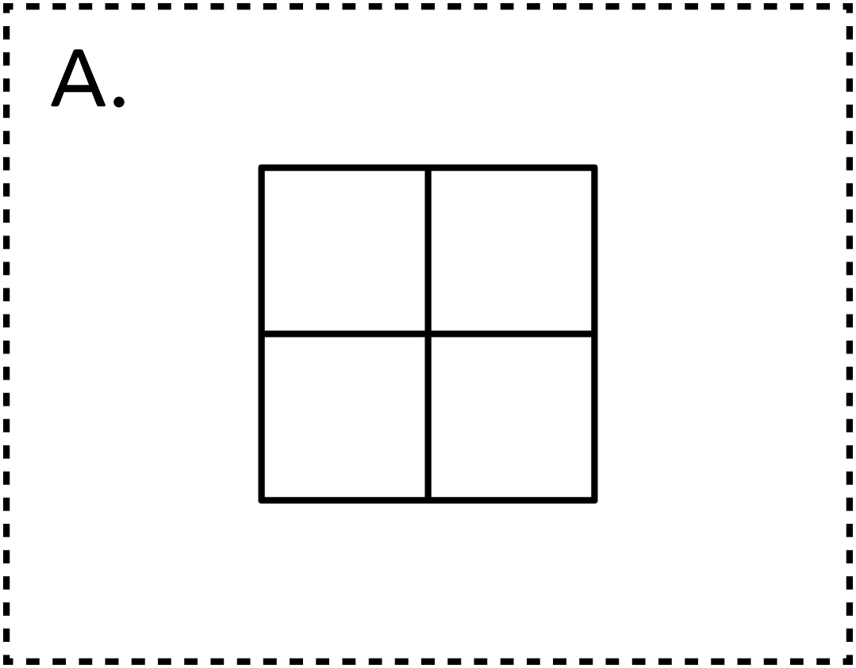

**Draw the Shape Cards**

**Math Every Day: Master 11b**

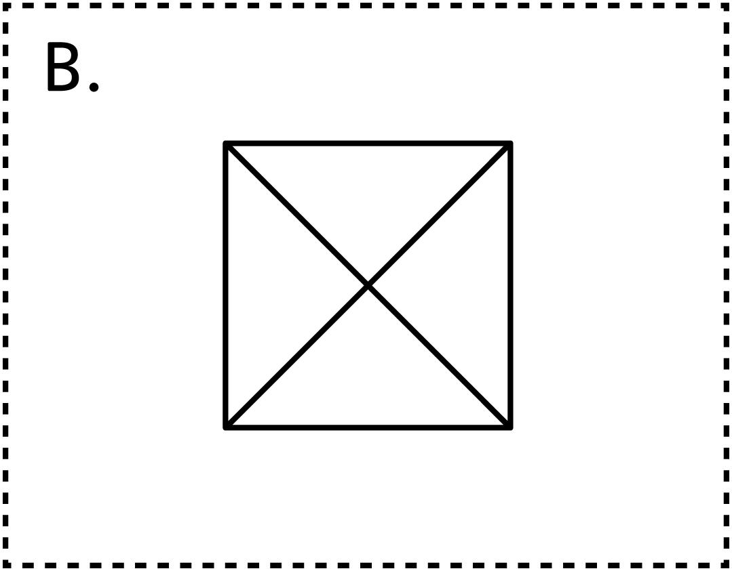

**Draw the Shape Cards**

**Math Every Day: Master 11c**

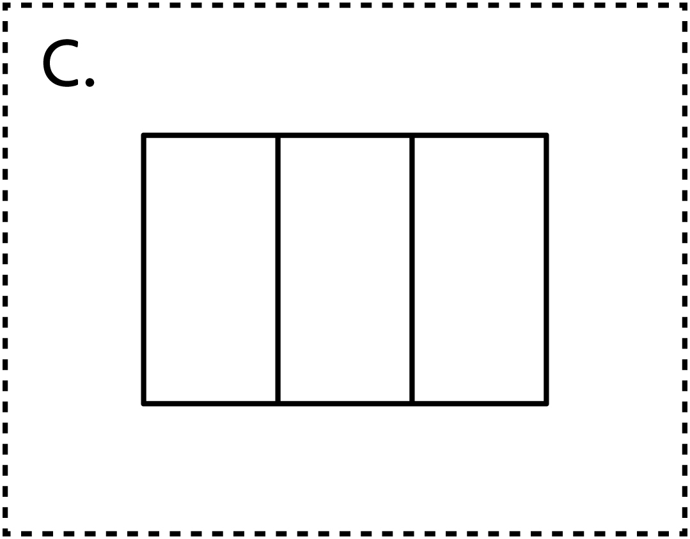

**Draw the Shape Cards**

**Math Every Day: Master 11d**

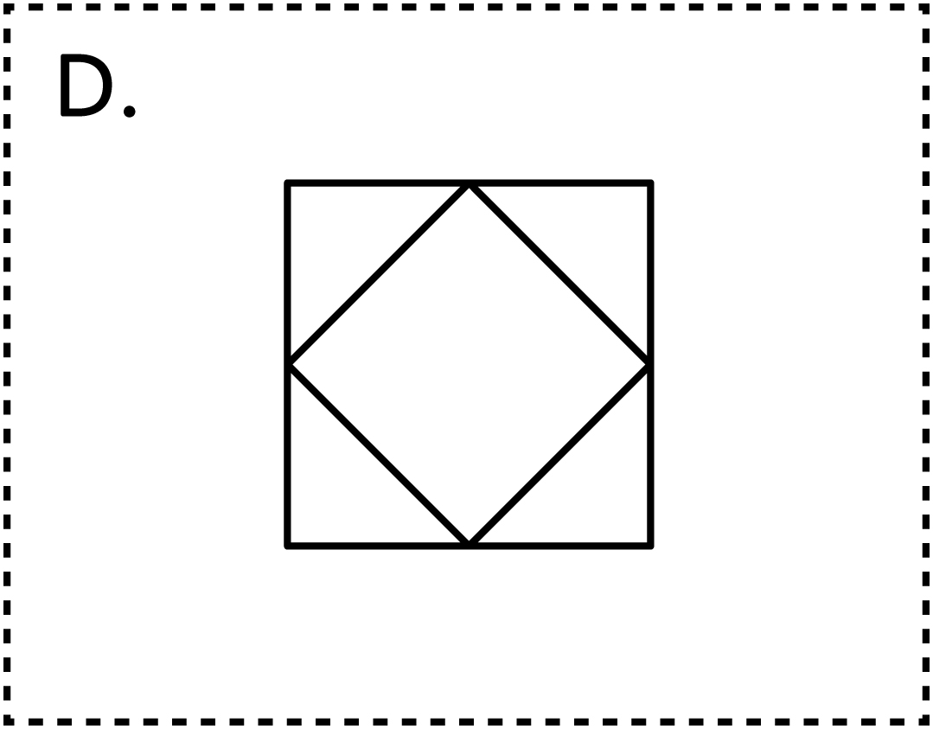

**Draw the Shape Cards**

**Math Every Day: Master 11e**

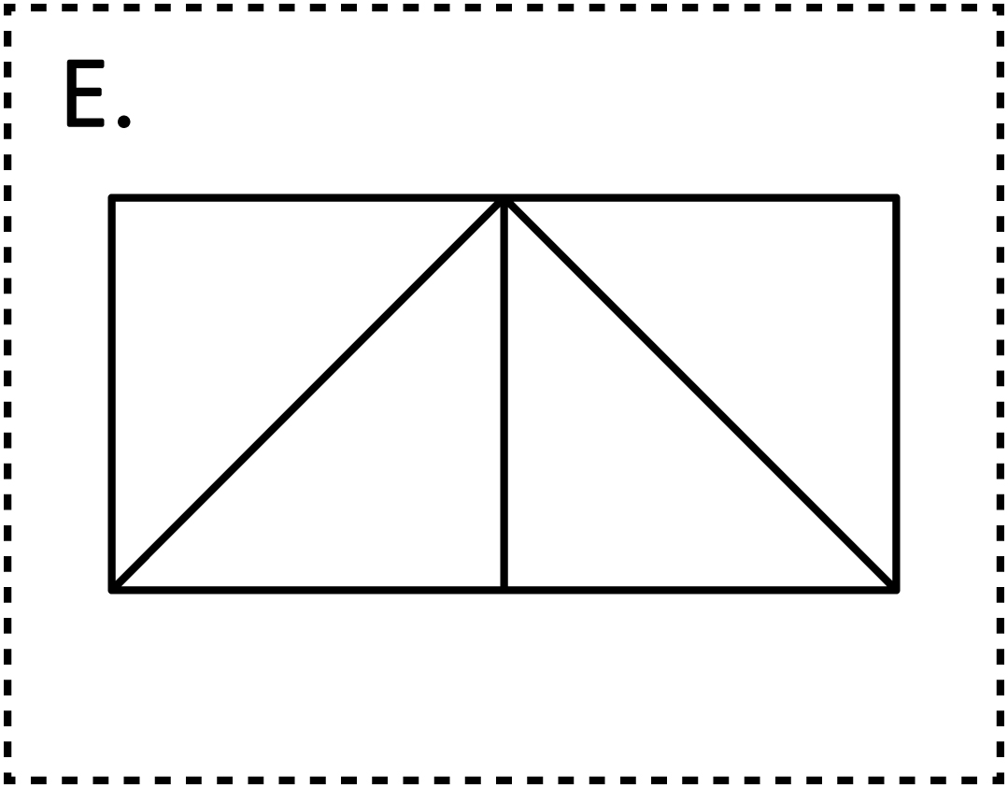

**Draw the Shape Cards**

**Math Every Day: Master 11f**

