Naming Fractional Amounts Behaviours/Strategies
- Student turns over two cards, but struggles  to visually compare fraction sizes and name  fractional amounts as he or she cannot name  the unit (i.e., does not know fraction words). | - Student turns over two cards, but struggles  to visually compare fraction sizes and name  fractional amounts, and matches number of  shaded parts to first word on card.  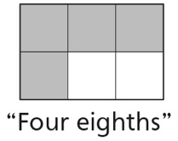 | - Student visually compares fraction sizes and  names some fractional amounts, but struggles  with sixths and eighths.
Observations/Documentation
- Student visually compares fraction sizes and  names fractional amounts, but struggles to  explain thinking. | - Student visually compares fraction sizes and  names fractional amounts, but does not realize that each shape can represent two fractional amounts.  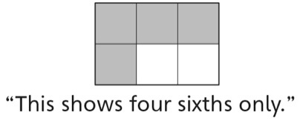 | - Student successfully visually compares fraction  sizes, names fractional amounts, and explains  thinking using math language.
Observations/Documentation

