**Domino Cards**

**Intervention: Master 6a**

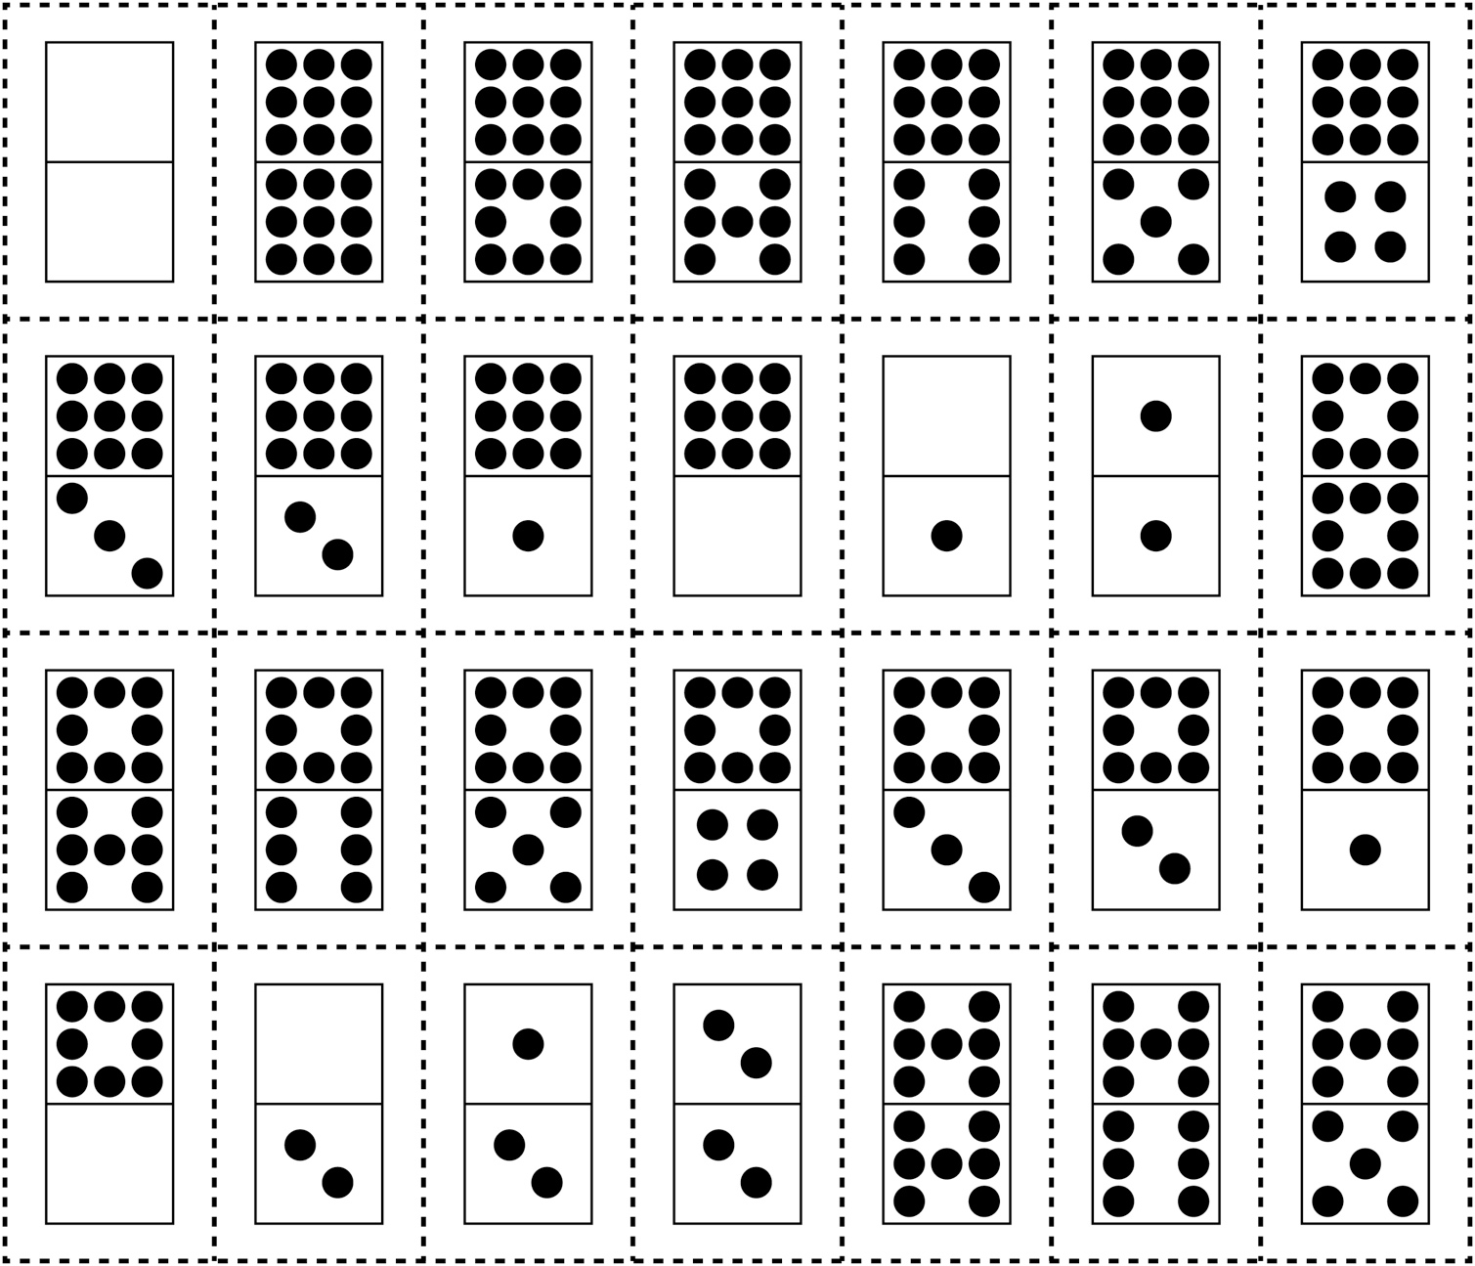

**Domino Cards**

**Intervention: Master 6b**

