Skip-Counting Backward Behaviours/Strategies
- Student takes away cubes, but struggles to  skip-count backward by factors of 10 (i.e., 2, 5) as he or she does not associate the skip-counting number with a quantity. | - Student counts back by 1s instead of skip-counting backward by factors of 10.  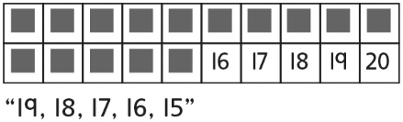 | - Student skip-counts backward by factors of 10, but does not recognize that the last counting  number tells how many.  “I’ll count the number of cubes left  on the chart by 1s.”
Observations/Documentation
- Student skip-counts backward by factors of 10, but relies on the numbers shown on the chart.  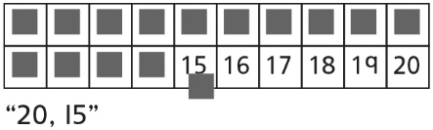 | - Student skip-counts backward by factors of 10, but finds one sequence (2s or 5s) easier than the other.  “It’s harder to count back by 2s.” | - Student fluently skip-counts backward by  factors of 10 (i.e., 2, 5).  “20, 18, 16, 14, 12, 10, 8, 6, 4, 2, 0”  “30, 25, 20, 15, 10, 5, 0”
Observations/Documentation

