Decomposing 10 into Parts Behaviours/Strategies
- Student selects counters randomly to  decompose 10 into parts. | - Student decomposes 10 into parts, but counts  three times to confirm how many.  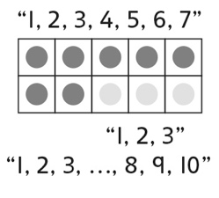 | - Student decomposes 10 into parts, but removes  all counters and starts again to find a new way.  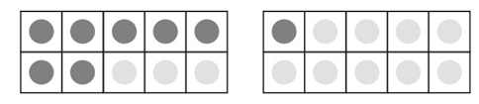
Observations/Documentation
- Student decomposes 10 into parts, but does not find all the ways. | - Student finds many ways to decompose 10 into parts, but does not consider 0 and 10. | - Student uses patterns to systematically find all  ways to decompose 10 into parts.
Observations/Documentation

