Exploring the Likelihood of Events Behaviours/Strategies
- Student reads card, but struggles to understand chance word used to describe likelihood of event. | - Student knows chance word used to describe  likelihood of event, but does not know where to start to make matching bag.  “How do I to make a bag where  a red counter is more likely?” | - Student knows chance word and makes  matching bag, but thinks only one bag is  possible.  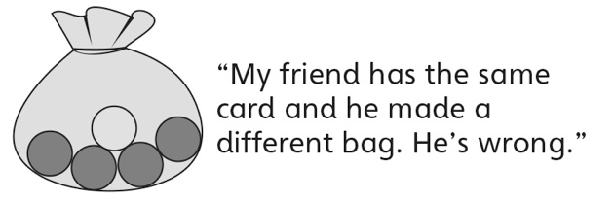
Observations/Documentation
- Student describes the likelihood of events and  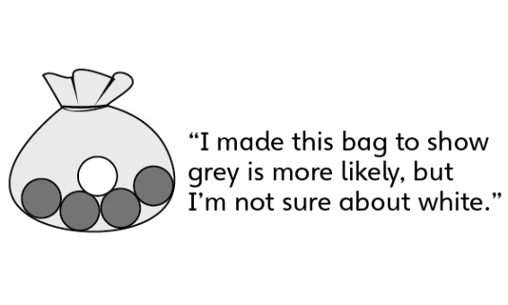  makes matching bag, but struggles to  describe the likelihood of complementary events happening. | - Student successfully describes the likelihood of events and makes matching bag, but does not understand why results of experiment do not match prediction. | - Student successfully describes the likelihood  of events, makes matching bag, and performs  simple experiments to verify predictions.
Observations/Documentation

