Conducting Surveys Behaviours/Strategies
- Student thinks of a topic, but is  unable to formulate a question or  does not include sample responses.  “My favourite animal is a dog.” | 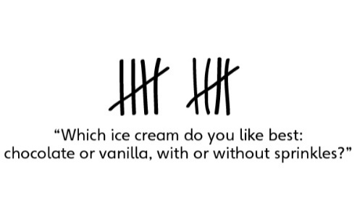  - Student formulates a question, but struggles to record responses using simple records. | - Student formulates a question that can be addressed through a survey and collects data in a two-way tally table, but struggles to use data to draw conclusions. | - Student successfully formulates  a question that can be addressed  through a survey, collects data  in a two-way tally table, and uses data to draw conclusions.
Observations/Documentation
Making, Reading, and Interpreting Graphs Behaviours/Strategies
- Student creates a display, but  struggles to translate information  from tally table to graph (i.e., numbers in tally table and  graph do not match). | - Student creates a display, but  bunches items together or  does not space items or shaded  rectangles equally. | - Student reads displays, but  struggles to interpret data to  answer questions. | - Student successfully interprets  displays by noting how many  more/less than other categories and identifying the mode(s).
Observations/Documentation

