Finding Equivalent addition and Subtraction Expressions Behaviours/Strategies
- Student chooses 3 random numbers and adds them together to see if they equal 50.  “How can I make 50 with 3 bean bag tosses? That’s hard.” | - Student models the tosses concretely, lining up concrete models end to end to prove equality, but doesn’t write related number sentences.  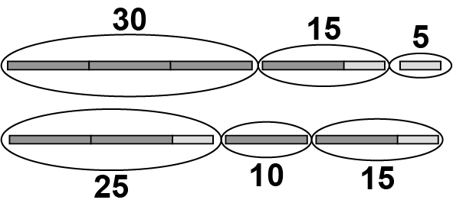  “They both have the same length.” | - Student models the tosses concretely and uses the values to prove equality, but has difficulty writing the related number sentences.  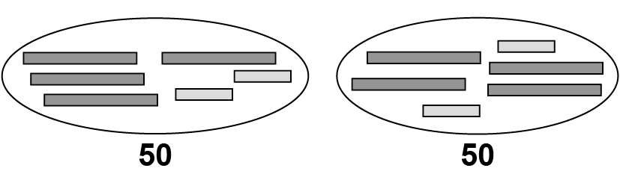  “They’re both 50, so they are the same.”
Observations/Documentation
- Student models the tosses pictorially and proves equality, but doesn’t write related number sentences or see equivalent expressions.  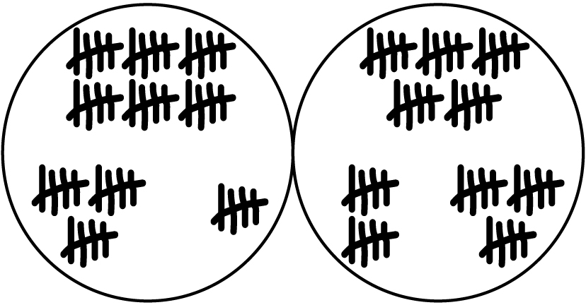  “They’re both 50.” | - Student writes number sentences to show the total scores, then compares the sums to prove equality.  30 + 15 + 5 = 50  25 + 10 + 15 = 50  “Since both add to 50,  I know that  30 + 15 + 5 = 25 + 10 + 15.” | - Student writes number sentences to show the total scores and uses reasoning to prove equality.  “It’s like 5 is taken away from 30 and given to 5.”  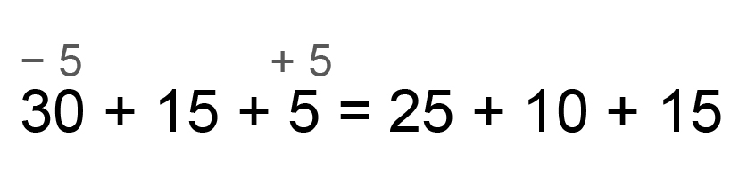
Observations/Documentation

