Equal or Not Equal? Number Sentences
Master 40a

Write = or ≠ in each box.
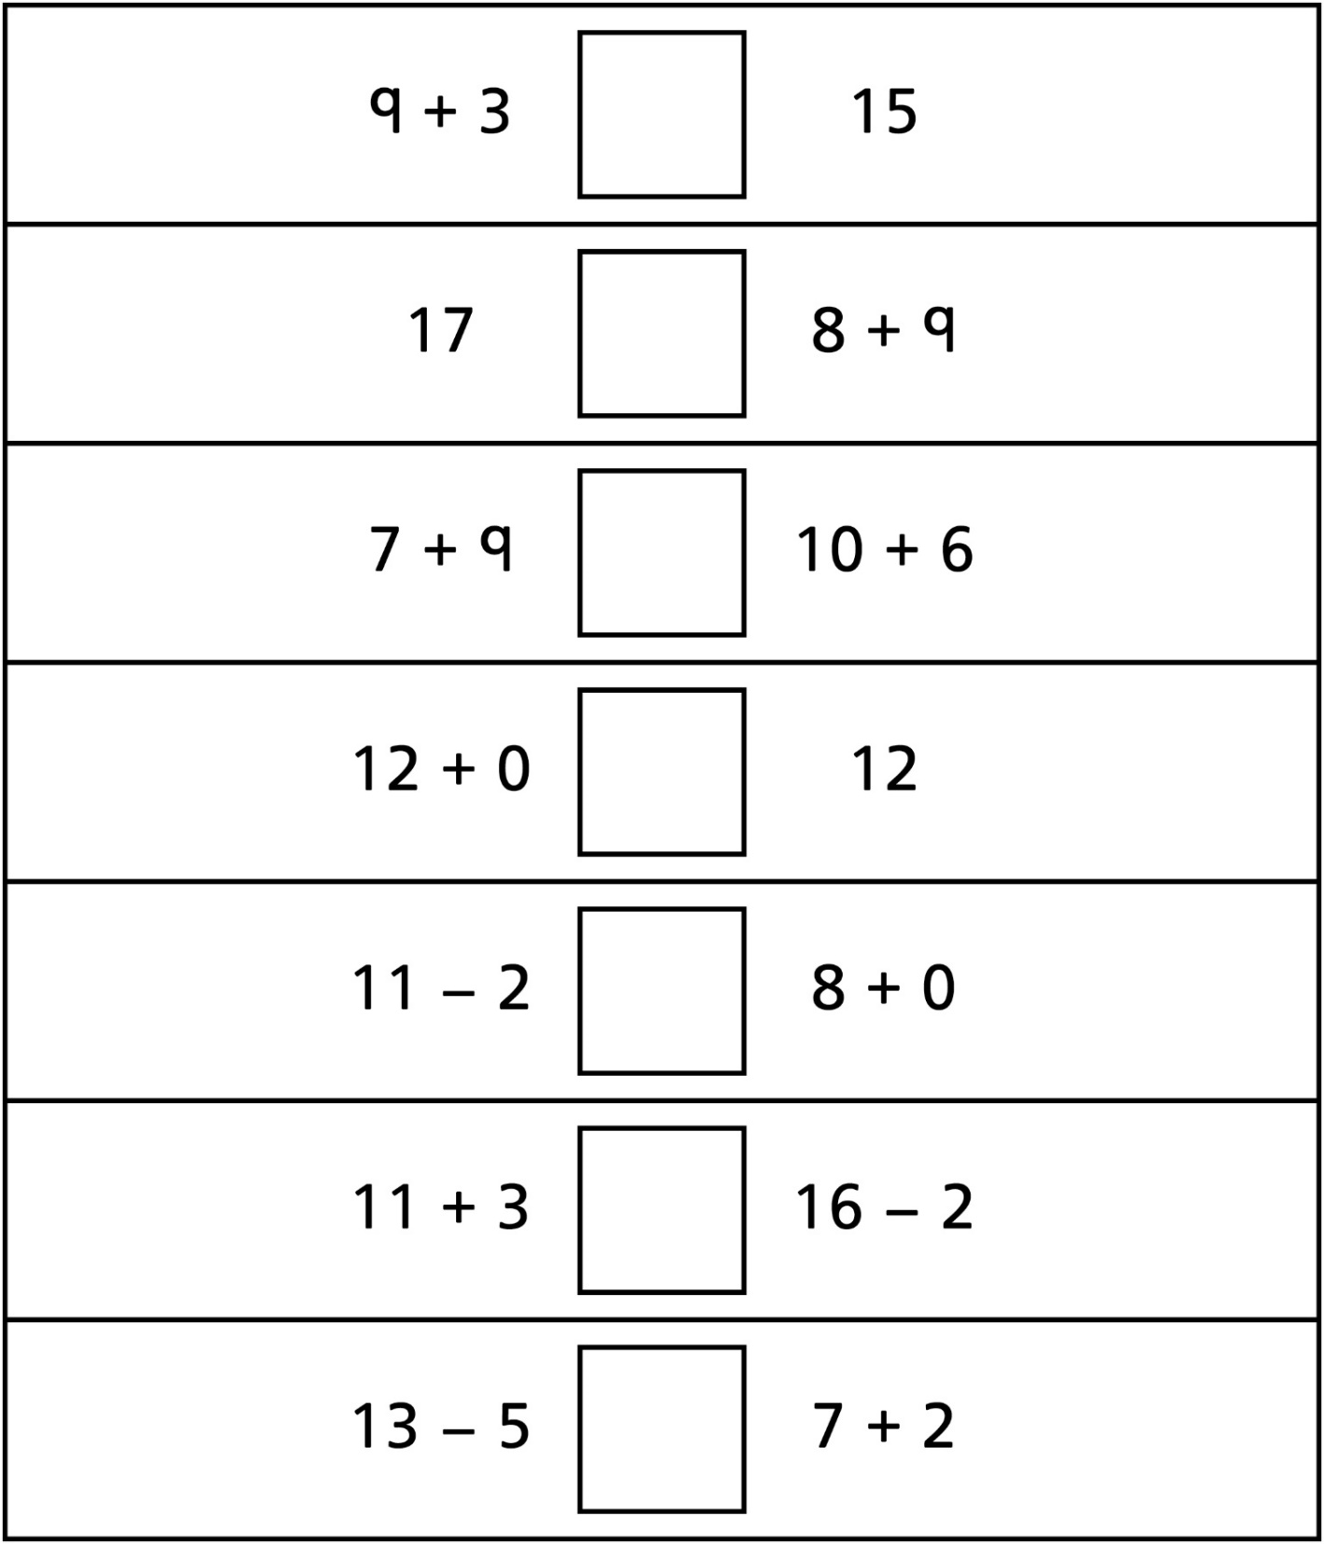
Equal or Not Equal? Number Sentences
Master 40b

Write = or ≠ in each box. 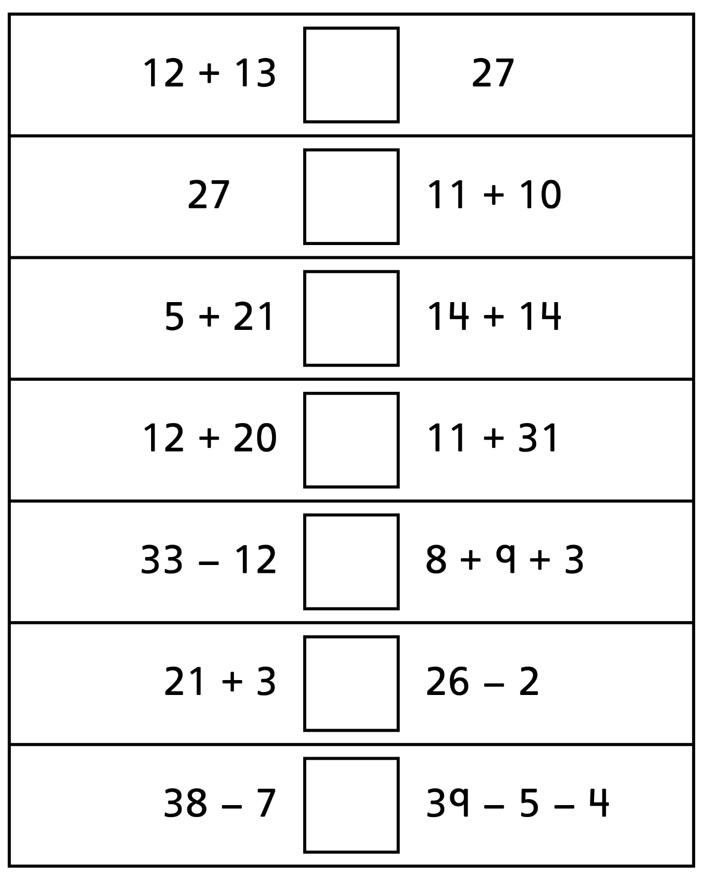
Equal or Not Equal? Number Sentences
Master 40c

(for Accommodations)
Write = or ≠ in each box.
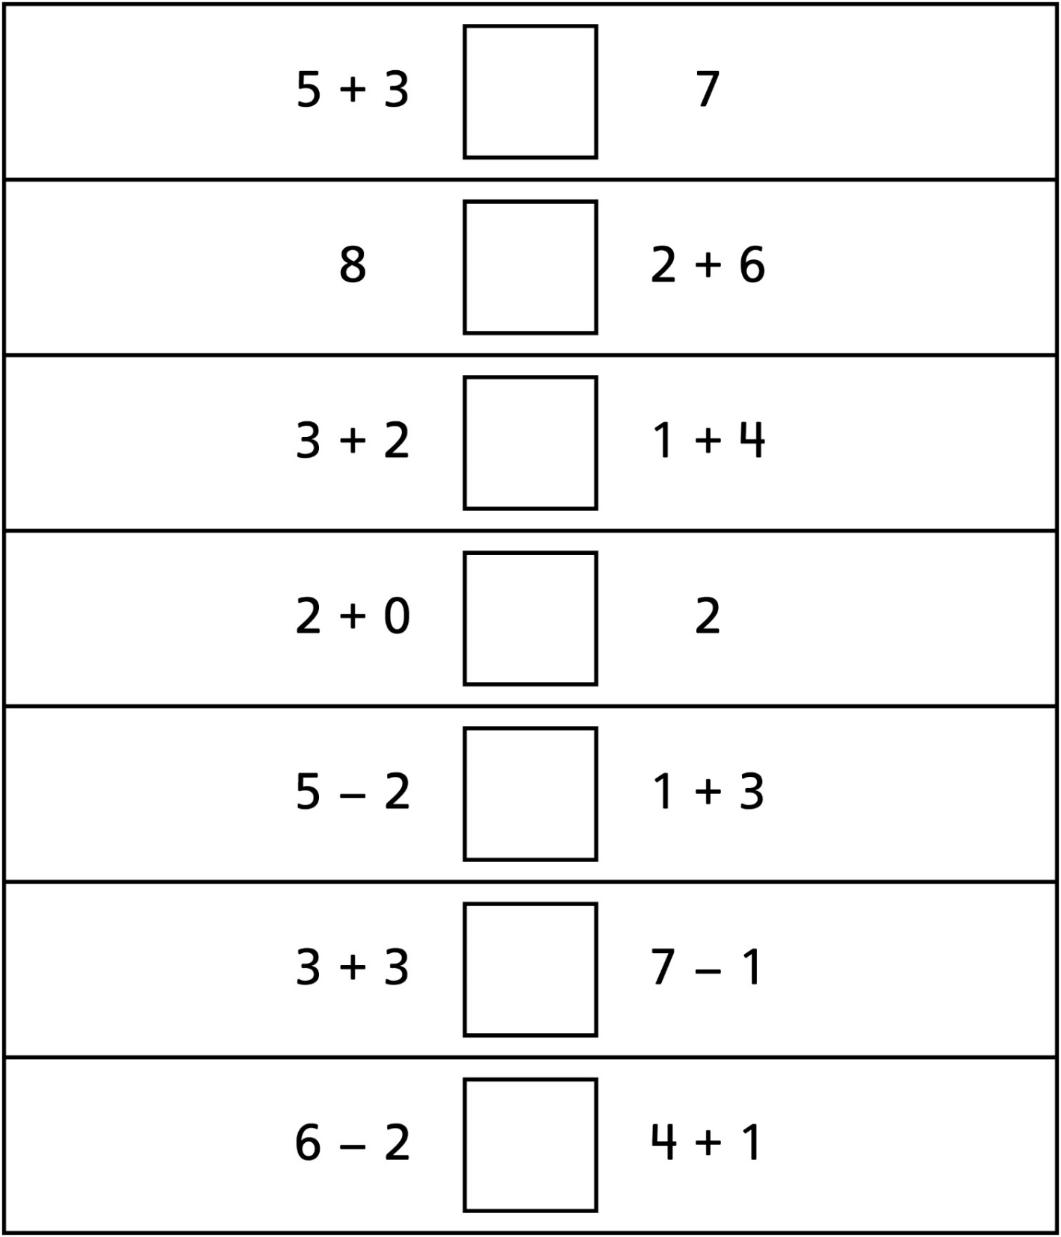
Equal or Not Equal? Number Sentences
Master 40d

(for Combined Grades Extension)
Write each side of a number sentence, then write = or ≠ in the box.
