Reproducing and Extending Increasing/Decreasing Patterns Behaviours/Strategies
- Student reproduces increasing/decreasing patterns, but is unable to extend patterns and adds tiles  randomly.  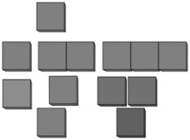 | - Student reproduces increasing/decreasing patterns, but struggles to extend them and does not add/subtract the same amount each time. | - Student reproduces increasing/decreasing patterns and attempts to extend them by adding/subtracting the same amount each time, but the amount added/subtracted is incorrect.
Observations/Documentation
- Student extends increasing/decreasing patterns by adding/subtracting the same amount each time, but shape of patterns is not maintained. | - Student reproduces and extends increasing/decreasing patterns, but is unable to write the pattern rule. | - Student successfully reproduces and extends  increasing/decreasing patterns and explains the rules.
Observations/Documentation

