Finding Errors and Missing Terms Behaviours/Strategies
- Student takes linking cubes, but struggles to  create an increasing/decreasing pattern. | - Student makes an increasing/decreasing pattern with missing terms or errors, but cannot identify the pattern rule of partner’s pattern to predict missing term(s) and correct errors.  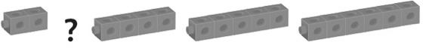 | - Student explains the rule, but has difficulty  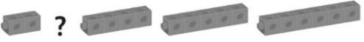  predicting missing term(s) in an increasing/decreasing pattern.  “Start at 2. Add 1 each time.”  3, 5, ?, 9, 11, …  “Start at 3. Add 2 each time.”
Observations/Documentation
- Student explains the rule, but has difficulty  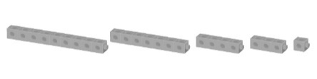  correcting errors in an increasing/decreasing pattern.  “Start at 9. Subtract 2 each time.”  18, 15, 12, 9, 6, …  “Start at 18. Subtract 3 each time.” | - Student predicts missing term(s) and corrects  errors in increasing/decreasing patterns, but struggles to explain how an error or missing term was found. | - Student successfully predicts missing term(s)  and corrects errors in increasing/decreasing patterns and justifies thinking.
Observations/Documentation

