Working with Patterns Involving Two Attributes Behaviours/Strategies
- Student chooses a pattern, but struggles to  recognize repeating pattern and is unable to  identify the two attributes that are changing. | - Student recognizes two attributes that are  changing in a repeating pattern, but struggles  to identify the core.  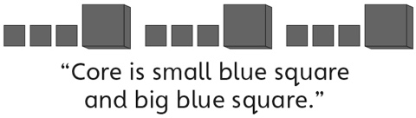 | - Student recognizes repeating patterns, but  struggles to create a core based on two  attributes.  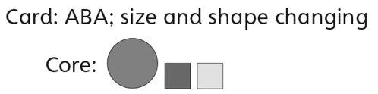
Observations/Documentation
- Student recognizes repeating patterns and  creates a core based on two attributes, but  struggles to extend the pattern.  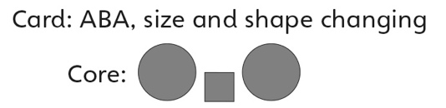 | - Student recognizes, extends, and creates  repeating patterns based on two attributes, but struggles to use math language when describing patterns. | - Student successfully recognizes, extends, and  creates repeating patterns based on two  attributes and uses math language when  describing patterns.  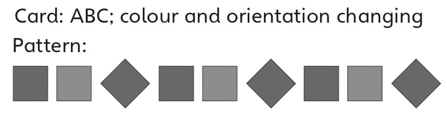
Observations/Documentation

