Modelling Dollar Amounts to $200 Behaviours/Strategies
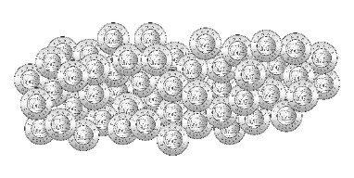  - Student models amount in one way (using smaller denominations).  “I used toonies to make $198 because I know how to skip-count by 2s: 2, 4, 6, …, 194, 196, 198.” | - Student models amount in more than one way, but trade was not accurate.  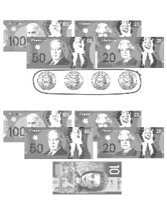  “I traded 4 toonies for a $10 bill.” | - Student models amount in more than one way and skip-counts to check.  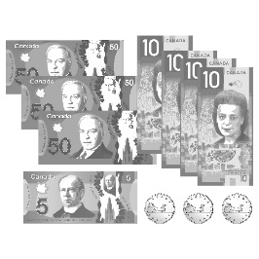  “50, 100, 150, 160, 170, 180, 190, 195, 196, 197, 198. The collection has a value of $198.” | 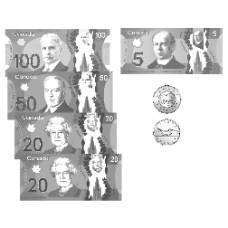  - Student successfully models amounts in different ways and finds fewest number of coins/bills needed.  “To find the fewest number, I traded smaller coins/bills for larger coins/bills until I could make no more trades.”
Observations/Documentation

