Decomposing Quantities to 20 Behaviours/Strategies
- Student uses play money, but  struggles to model $20 (unable to  decompose quantities to 20).  “I don’t know what I need to  make $20.” | - Student models savings, but  chooses money randomly to pay  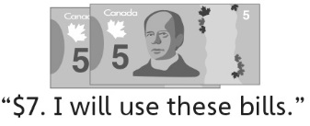  for an item (unable to decompose quantities to 20). | - Student decompose quantities  to 20, but cannot find the exact  amount in savings needed to pay  for an item.  “I can’t make exactly $4.” | - Student successfully and flexibly  decomposes quantities to 20.
Observations/Documentation
Subtracting Money Amounts Behaviours/Strategies
- Student uses money to pay for an item, but cannot subtract with  quantities to 20 to determine how  much is left in savings. | - Student counts to determine  how much is left in savings as  he or she cannot subtract with  quantities to 20. | - Student subtracts with quantities  to 20, but is unable to use symbols and equations to represent subtraction situations.  “I can’t write a number sentence.” | - Student subtracts with quantities  to 20 and uses symbols and  equations to represent subtraction situations.  “20 − 7 = 13”
Observations/Documentation

