Repeated Subtraction and Division Behaviours/Strategies
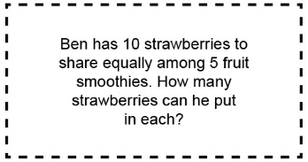  - Student identifies what is known and what needs to be found in division problem.  “I know there are 5 equal groups, and I need to find how many are in each group.” |  | - Student models and concretely shares items equally.  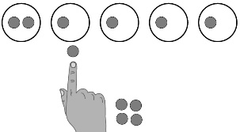  “1 for you and 1 for you,…” |  | 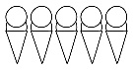  - Student uses drawings to represent equal sharing and grouping situations.  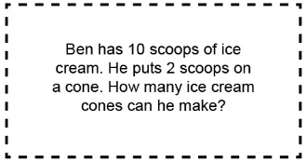  “I drew 2 scoops of ice  cream on each cone until  I had 10 scoops altogether. There are 5 cones.”
Observations/Documentation
Repeated Subtraction and Division Behaviours/Strategies
- Student uses repeated subtraction to represent equal sharing and grouping situations.  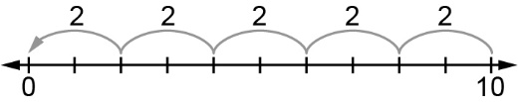  10 – 2 – 2 – 2 – 2 – 2 = 0  “There are 5 groups of 2.” |  | - Student understands the relation between repeated subtraction and division.  10 – 2 – 2 – 2 – 2 – 2 = 0  10 ÷ 2 = 5 |  | - Student models and solves equal sharing and grouping situations using a variety of strategies and uses inverse relations to check.  10 ÷ 2 = 5  “Since 5 × 2 = 10. I know my answer is correct.”
Observations/Documentation

