Four in a Line Cards
Master 92a

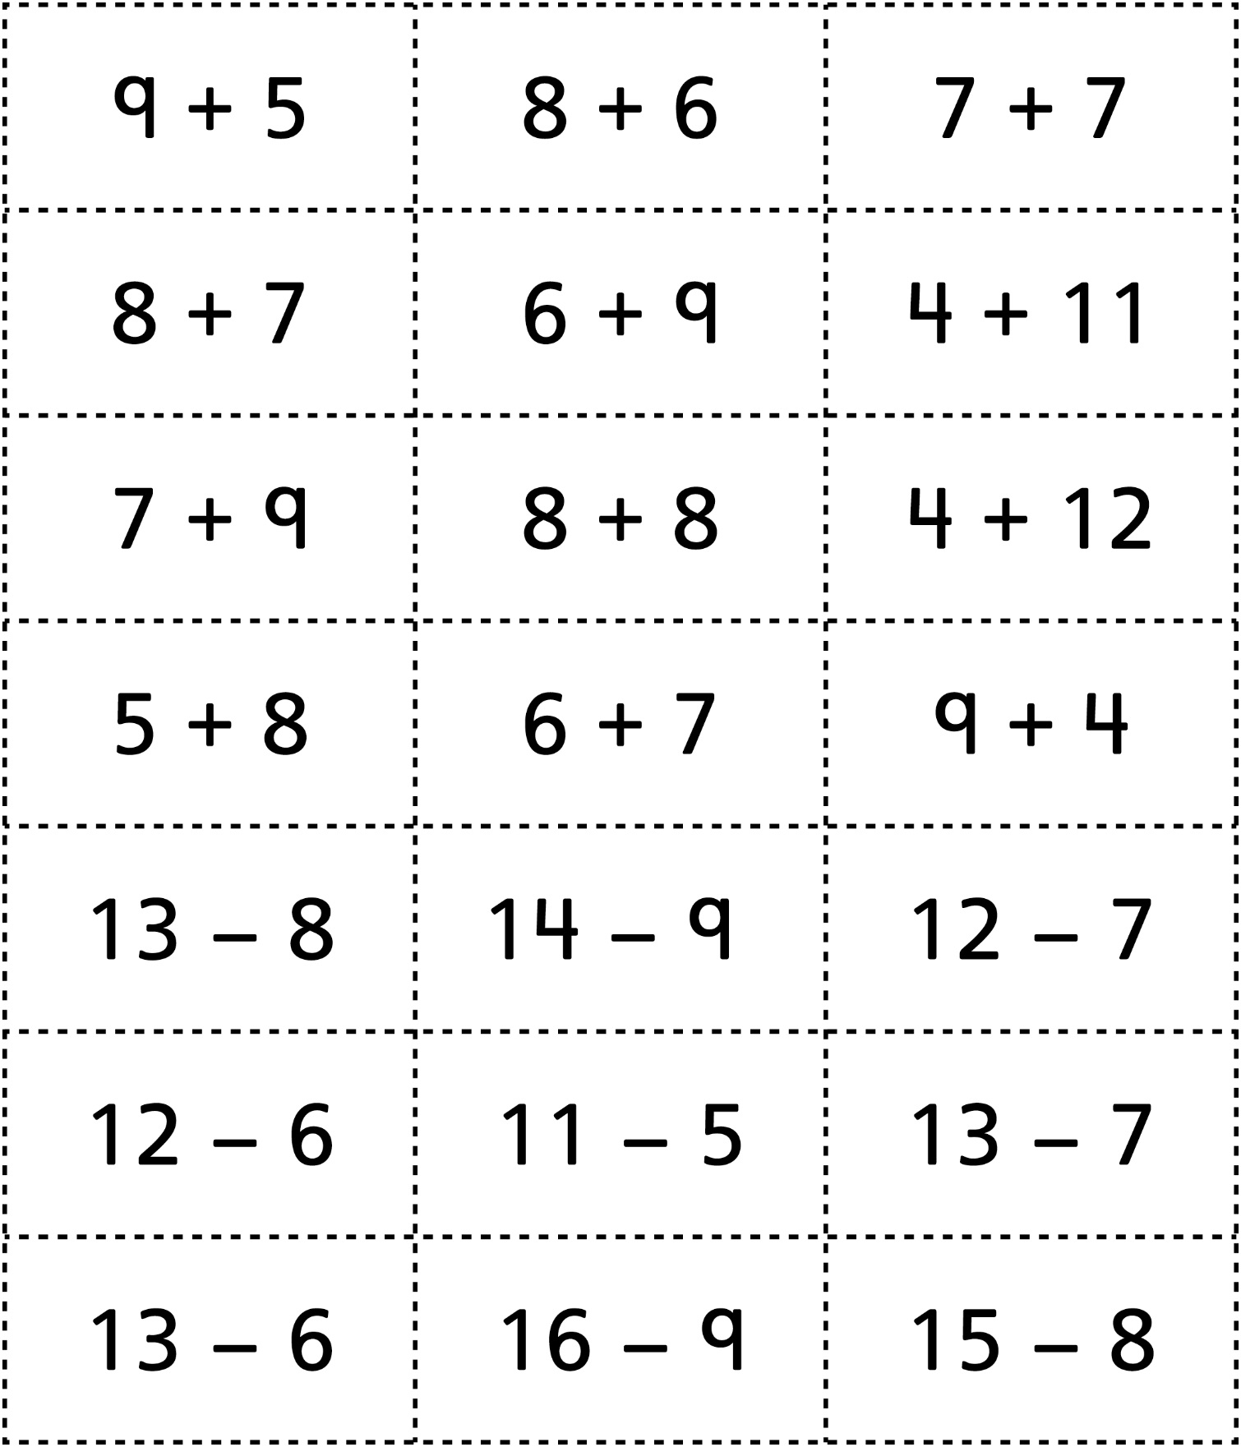

Four in a Line Cards
Master 92b

(for Combined Grades Extension)

