**Who Am I? Cards**

**Master 72a**

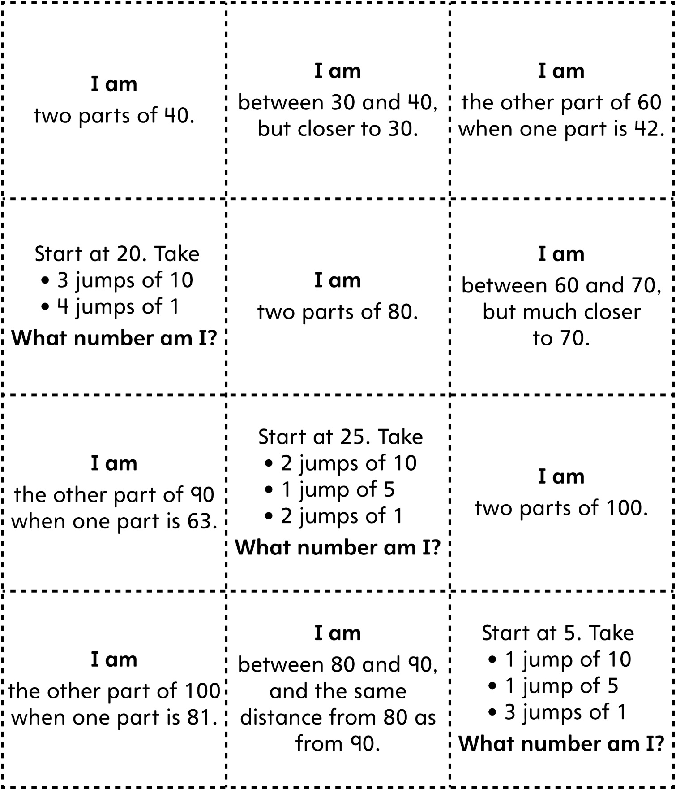

**Who Am I? Cards**

**Master 72b**

**Who Am I? Cards (for Accommodations)**

**Master 72c**

