Composing and Decomposing Numbers to 200 Behaviours/Strategies
- Student models a 2-digit number using tens and ones (one way).  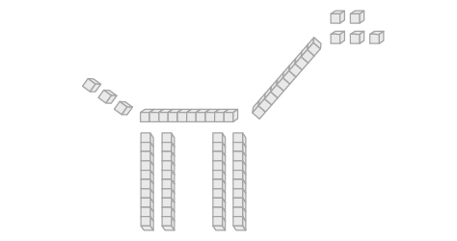  “I modelled 68 on my mat, then used to blocks to make a giraffe.” | - Student models a 3-digit number using tens and ones (one way).  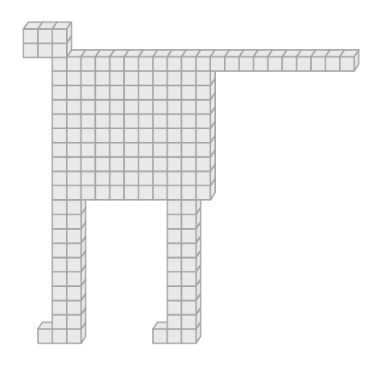  “I modelled 168 on my mat, then used to blocks to make a tiger.” | - Student models a 3-digit number another way, but trade was not accurate.  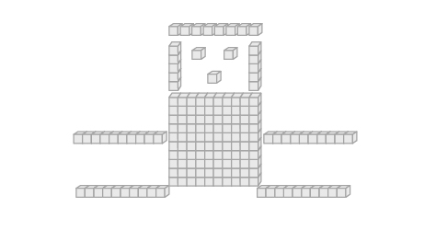  “I traded 2 rods for 13 cubes. That’s how many more I needed to make the face.”
Observations/Documentation
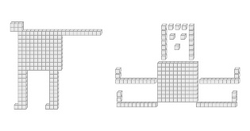  - Student models a 3-digit number using hundreds, tens, and ones (more than one way).  “I traded 2 rods for 20 unit cubes.” | 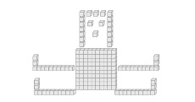  - Student models a 3-digit number in different ways but struggles to understand value of the blocks.  “100 hundreds (body) + 20 ones (head) + 40 tens + 8 ones (legs) = 168.” | 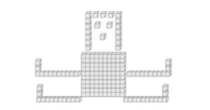  - Student successfully models a 3-digit number in different ways and records the related addition sentences.  “100 (body) + 20 (head) + 48 (legs) = 168.”
Observations/Documentation

