Decomposing Numbers on a Number Line Behaviours/Strategies
- Student chooses a card, but struggles to  decompose numbers into parts using a  number line.  “I don’t know what to do.” | - Student decomposes numbers into parts using a number line, but always takes jumps of 1. | - Student decomposes numbers into parts using a number line, but only takes jumps of 1 and 10.  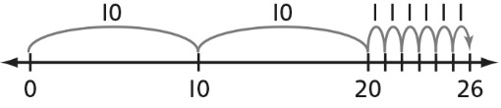
Observations/Documentation
- Student flexibly decomposes numbers into parts using a number line, but struggles to identify the way that takes the fewest jumps.  “I found lots of ways to jump to the number.” | - Student flexibly decomposes numbers into parts using a number line, but struggles to record the jumps in her or his math journal.  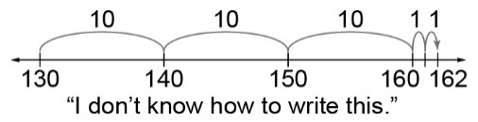 | - Student flexibly decomposes numbers into parts using a number line, identifies the most efficient way, and records work.
Observations/Documentation

