Comparing Fractions of a Whole Behaviours/Strategies
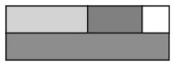  - Student takes a rod, but struggles to partition it into equal parts, and parts are not equal. | - Student takes a rod, but struggles to partition  it into equal parts, and parts do not cover whole exactly. | - Student partitions wholes into equal parts, but  struggles to name the unit (does not know  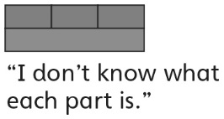  fraction words).
Observations/Documentation
- Student partitions wholes into equal parts  and names the unit, but does not realize that  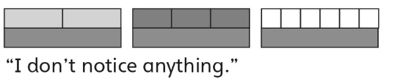  partitioning a whole into more equal parts  produces smaller parts. | - Student partitions wholes into equal parts and  names the unit, but struggles to compare with  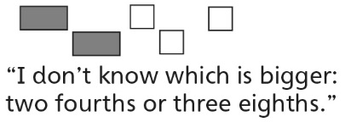  unit fractions. | - Student successfully partitions wholes into  equal parts, names the unit, relates the size of  parts to the number of equal parts in a whole,  and compares with unit fractions.
Observations/Documentation

