Composing and Decomposing Numbers Behaviours/Strategies
- Student decomposes number into units of tens and leftover ones, but has more than 10 cubes in the Ones column.  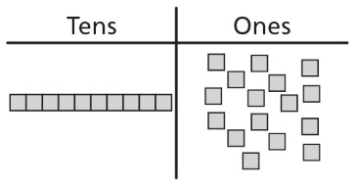 | - Student decomposes number into units of tens and leftover ones, but does not realize that one ten is the same as 10 ones.  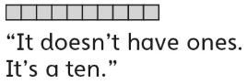 | - Student decomposes number into units of tens and leftover ones, but confuses the number of tens with the number of cubes in the rods.  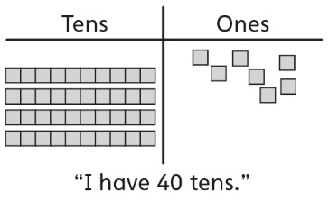 | - Student decomposes number into units of tens and leftover ones, but is unable to relate the number of tens and leftover ones to the digits of the number (cannot read the number).  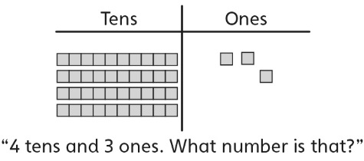
Observations/Documentation
- Student decomposes number into units of tens and leftover ones, but cannot write the number.  “5 tens and 1 one, fifty-one.  How do I write it?” | - Student decomposes number into units of tens and leftover ones, and counts on with cubes to determine how many more ones are needed to make another ten.  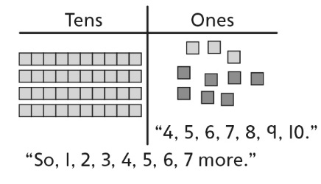 | - Student decomposes number into units of tens and leftover ones and counts on with fingers to determine how many more ones are needed to make another ten.  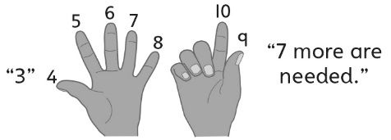 | - Student successfully writes, reads, composes, and decomposes two-digit numbers as units of tens and leftover ones.
Observations/Documentation

