**Building Numbers Cards**

**Master 35a**

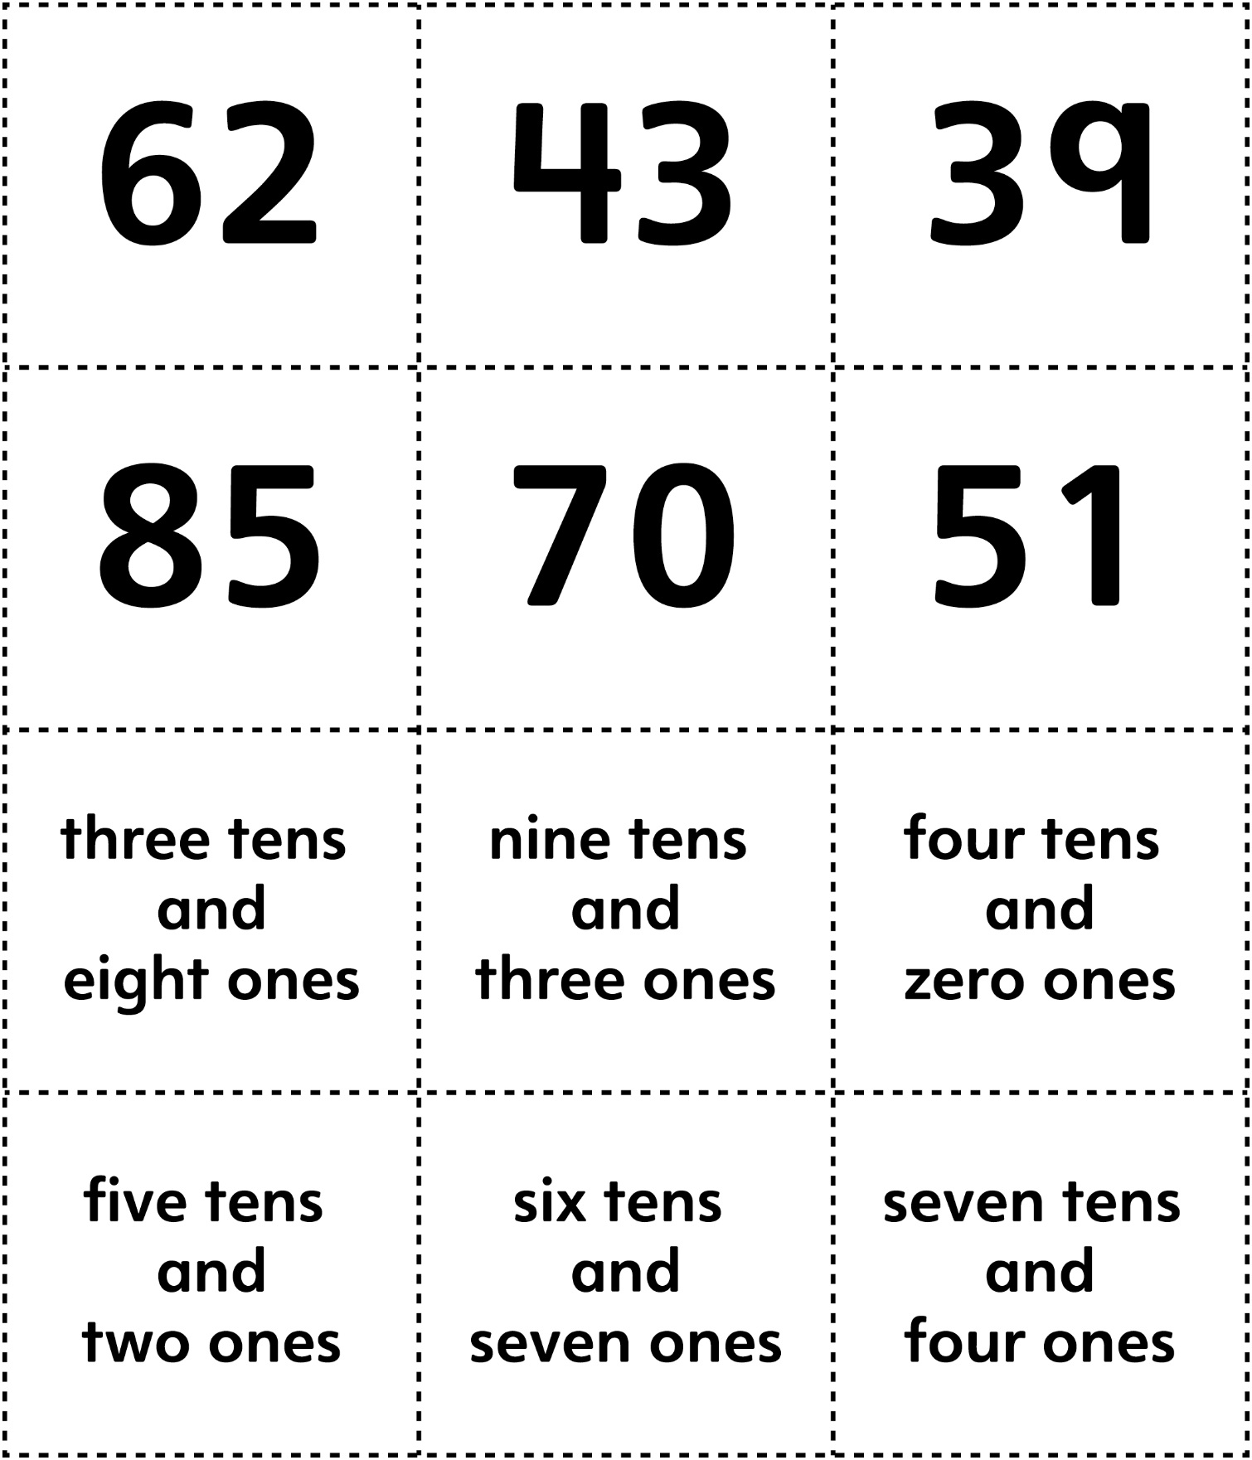

**Building Numbers Cards (for Accommodations)**

**Master 35b**

