My Lock is Stuck!
Master 25a

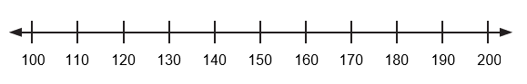
Plot the 4 codes on the number line.
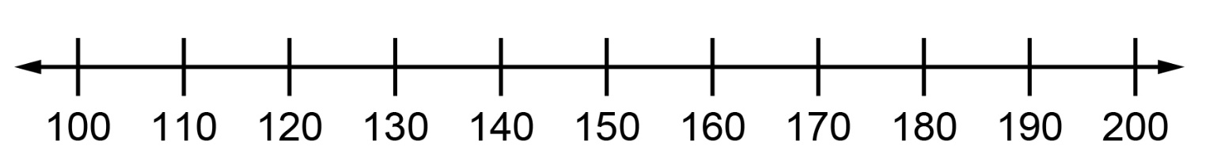
Circle the correct code.
Thanks for helping me open my lock!

My Lock is Stuck! (Accommodation)
Master 25b

Write 4 codes between 10 and 99.

Plot the 4 codes on the number line.
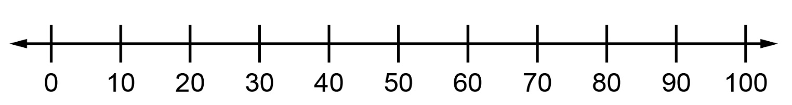
Circle the correct code.
Thanks for helping me open my lock!
My Lock is Stuck! (Extension)
Master 25c

Write 3 codes less than 150 and 3 codes greater than 150.

Plot the 6 codes on the number line.
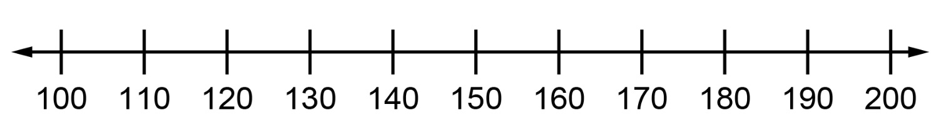
Circle the correct code.
Thanks for helping me open my lock!
My Lock is Stuck! (Combined Grades)
Master 25d

Write 6 codes between 100 and 999.

Plot the 6 codes on the number line.
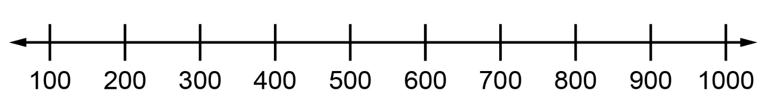

Circle the correct code.
Thanks for helping me open my lock!

