Comparing and Ordering Behaviours/Strategies
- Student makes two-digit numbers, but struggles to name them.  23 56  “Two three and five six.” | 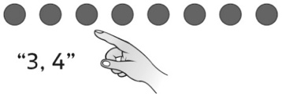  - Student models numbers with objects, but is unable to coordinate number words with counting actions (does not say one word for each object). | - Student makes two-digit numbers, but places them randomly on the cards without giving any thought to order.  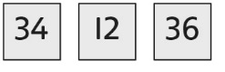 | - Student compares and orders  quantities using one-to-one  matching (models numbers with  counters).  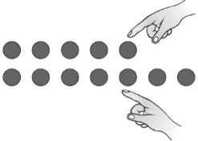
Observations/Documentation
- Student compares and orders  quantities using counting (models  numbers with counters).  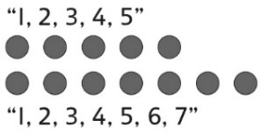 | - Student compares and orders  written numbers using  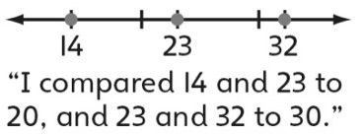  benchmarks. | - Student successfully compares  and orders written numbers using  benchmarks, but uses comparative language incorrectly.  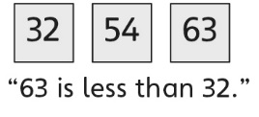 | - Student successfully compares  and orders written numbers using  benchmarks and uses comparative language correctly.
Observations/Documentation

