**Skip-Counting Backward Game Cards**

**Master 16a**

**(Part 1)**

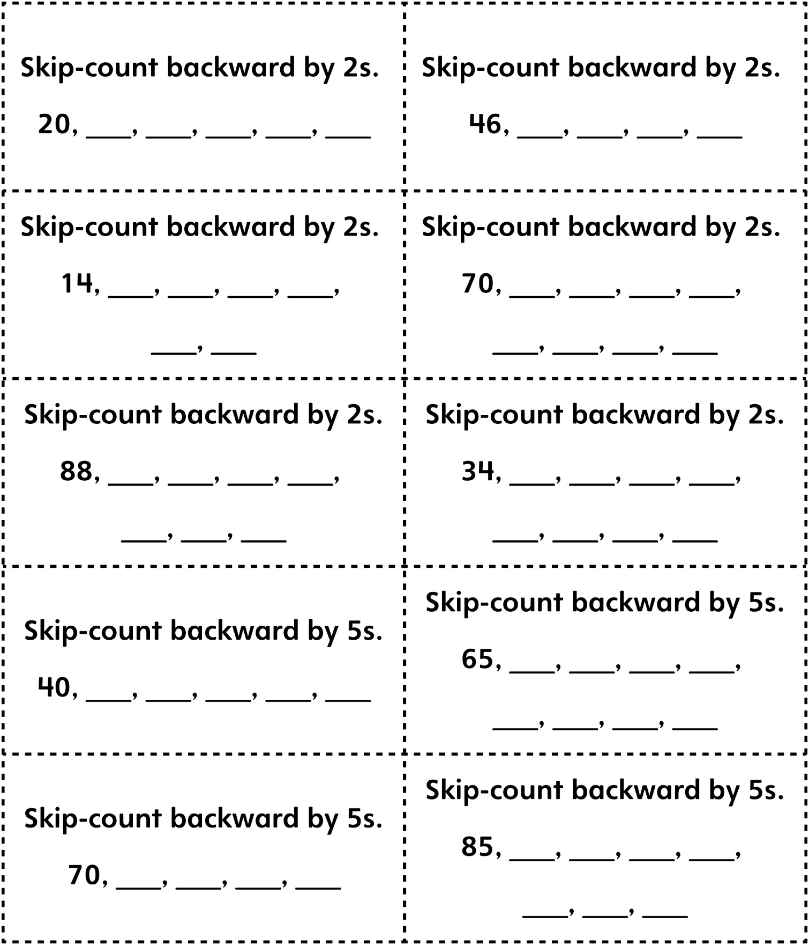

**Skip-Counting Backward Game Cards**

**Master 16a**

**(Part 2)**

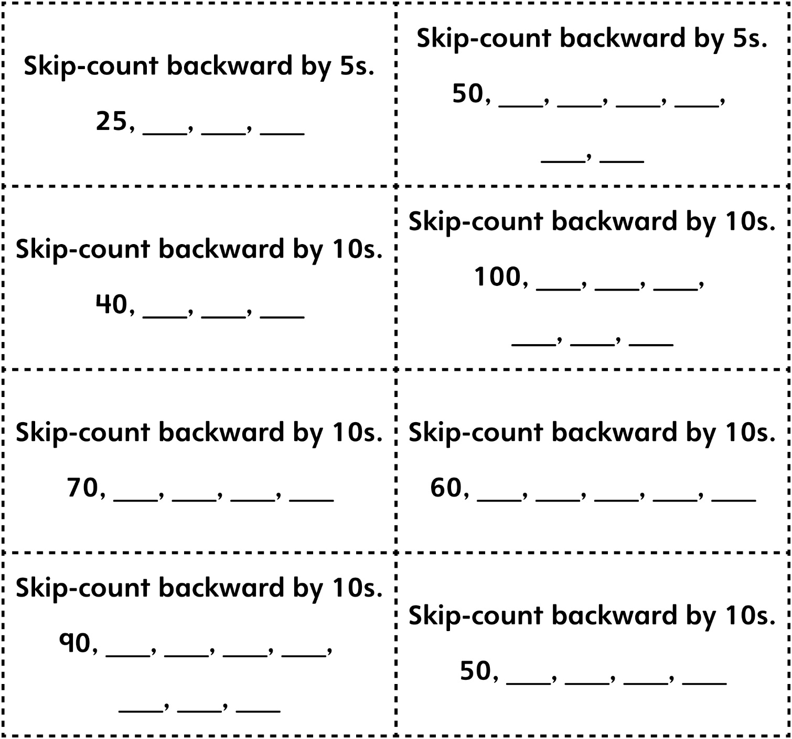

**Skip-Counting Backward Game Cards (Extension) (Part 1)**

**Master 16b**

 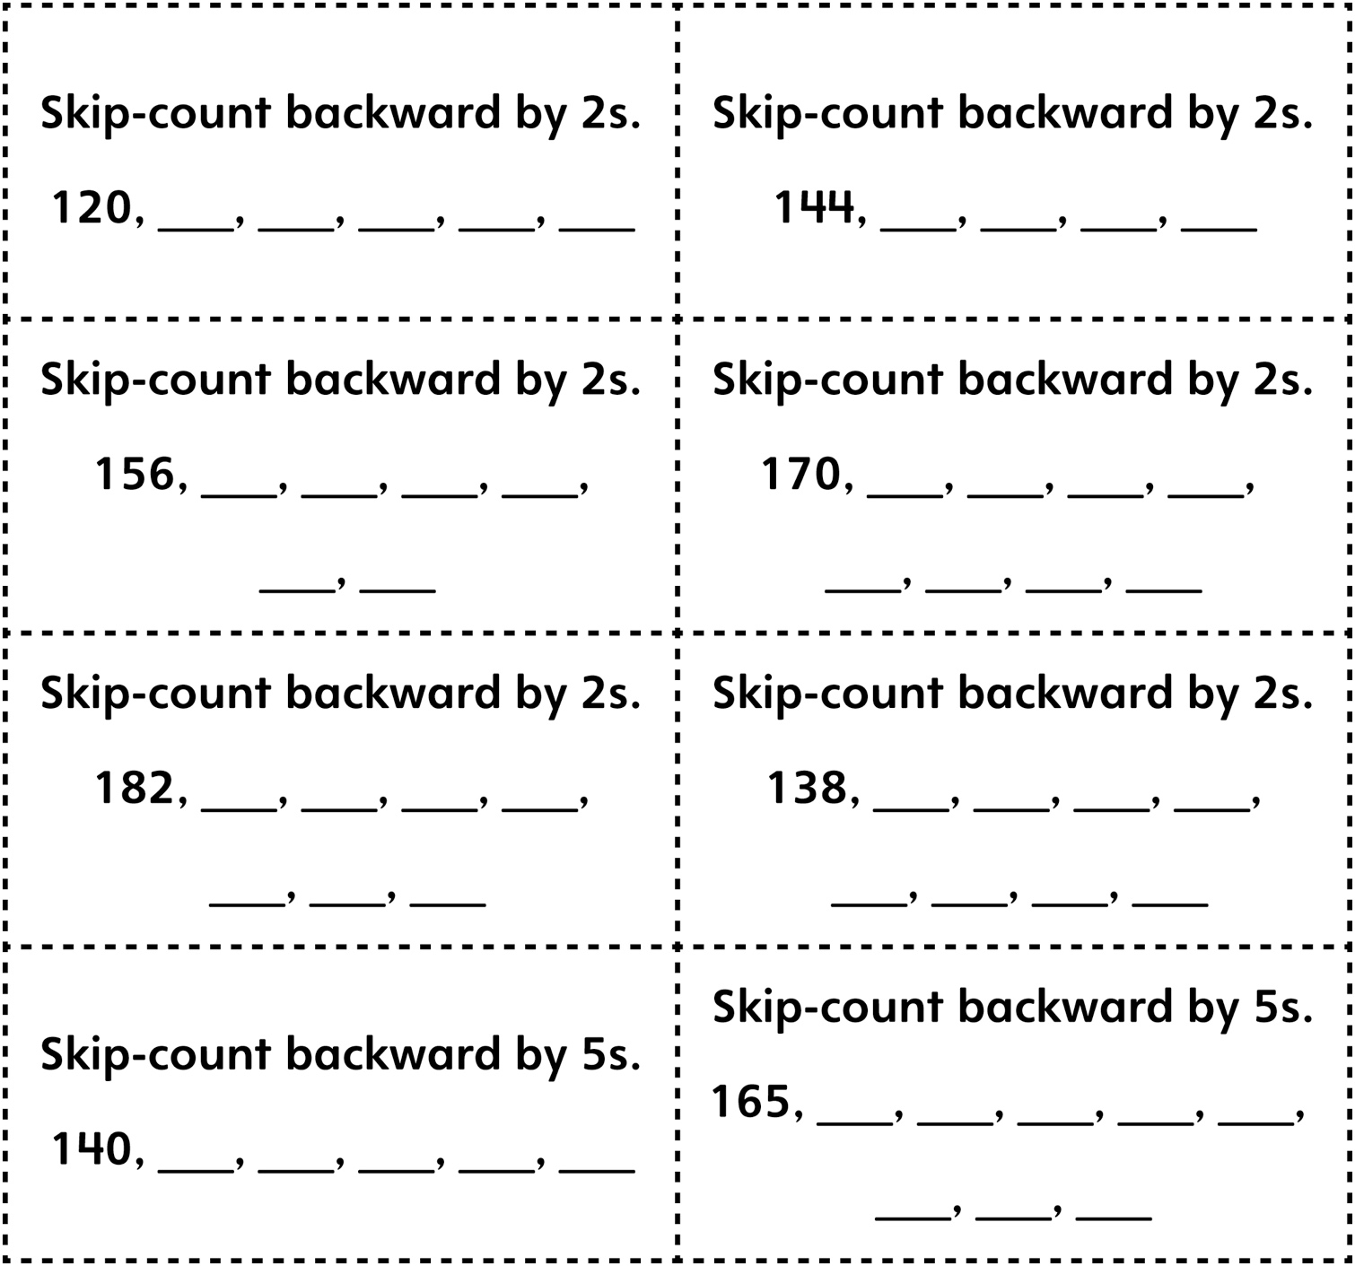

**Skip-Counting Backward Game Cards (Extension) (Part 2)**

**Master 16b**

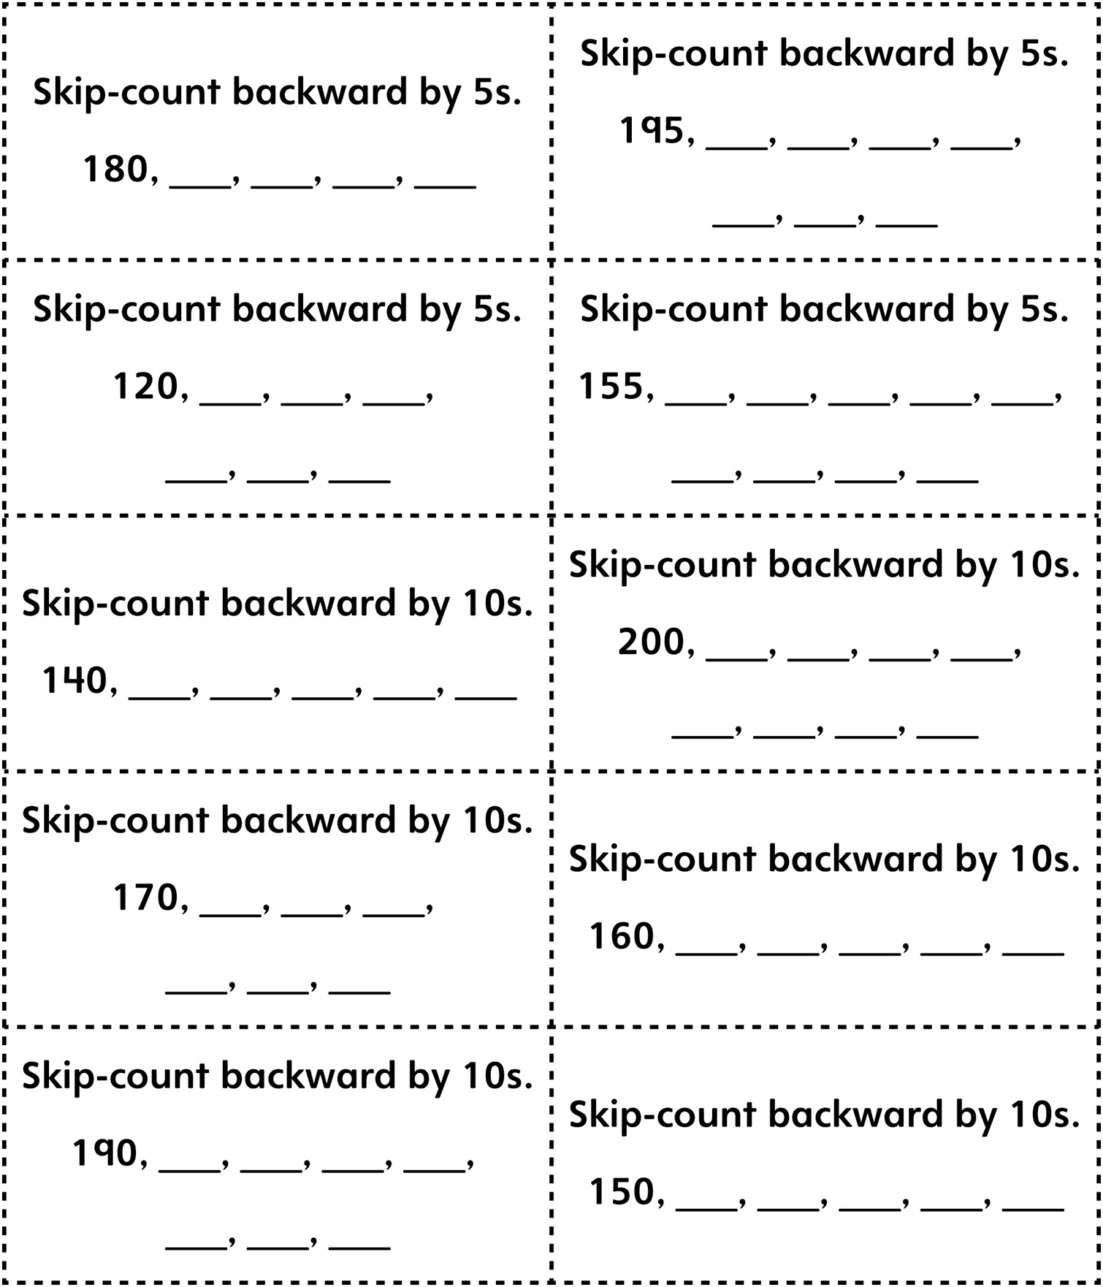

**Skip-Counting Backward Game Cards (Combined Grades) (Part 1)**

**Master 16c**

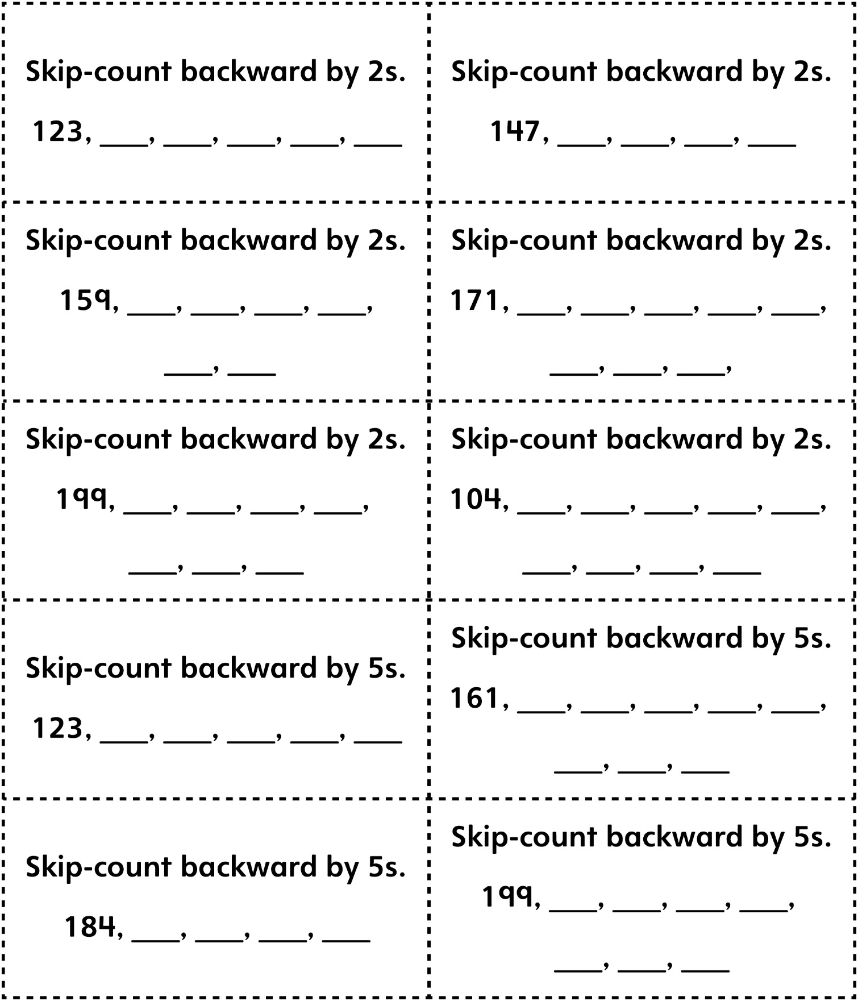

**Skip-Counting Backward Game Cards (Combined Grades) (Part 2)**

**Master 16c**

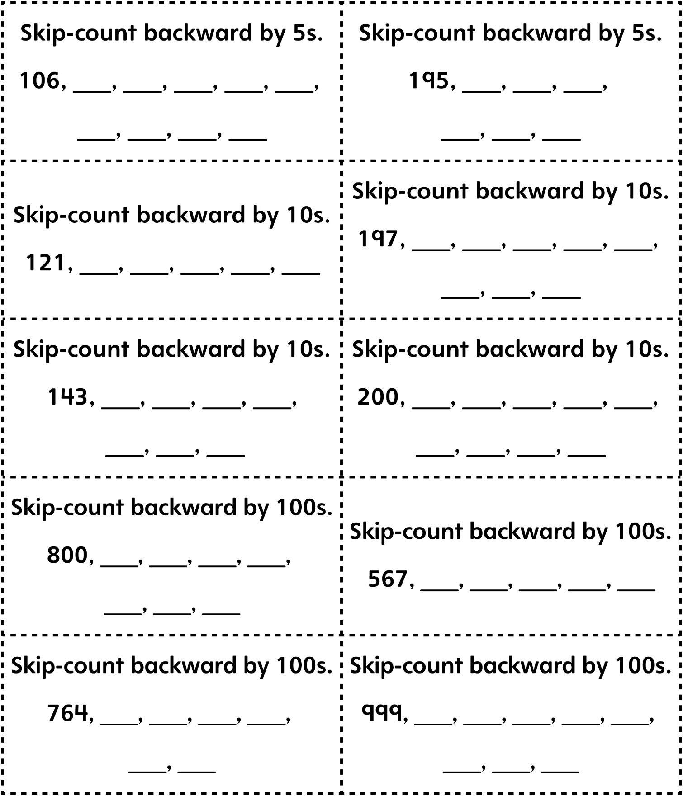

**Skip-Counting Backward Game Cards (Blank Cards)**

**Master 16d**



|  |  |
| --- | --- |
|  |  |
|  |  |
|  |  |
|  |  |
|  |  |