Skip-Counting from Any Number Behaviours/Strategies
- Student uses correct start number, but reverts  to the skip-counting from 0 sequence when  skip-counting by factors of 10 (i.e., 2, 10) from  any given number.  “3, 10, 20, 30, …” | - Student uses correct start number, but mixes  up the numbers or omits numbers in the  skip-counting sequence when skip-counting by factors of 10 from any given number.  “3, 13, 33, 43, …” | - Student skip-counts by factors of 10 from any  given number and uses fingers or the hundred  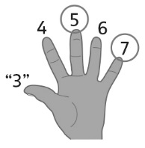  chart to help.
Observations/Documentation
- Student skip-counts by 5s, 10s, and 20s from any given number, but loses track of number of times counted.  “53, 73, 93, 113. Can I stop yet?” | - Student skip-counts by 5s, 10s, and 20s from any given number, but struggles to identify errors or missing numbers in partner’s skip-counting sequences.  “101, 111, 122, 131, 141, …”  “I’m not sure if she is correct.” | - Student fluently skip-counts 5s, 10s, and 20s  from any given number.  “95, 100, 105, 110, 115, …”  “88, 108, 128, 148, 168, …”
Observations/Documentation

