Skip-Counting by 5s Spider Webs
Master 7a

Start at 0. Skip-count by 5s.

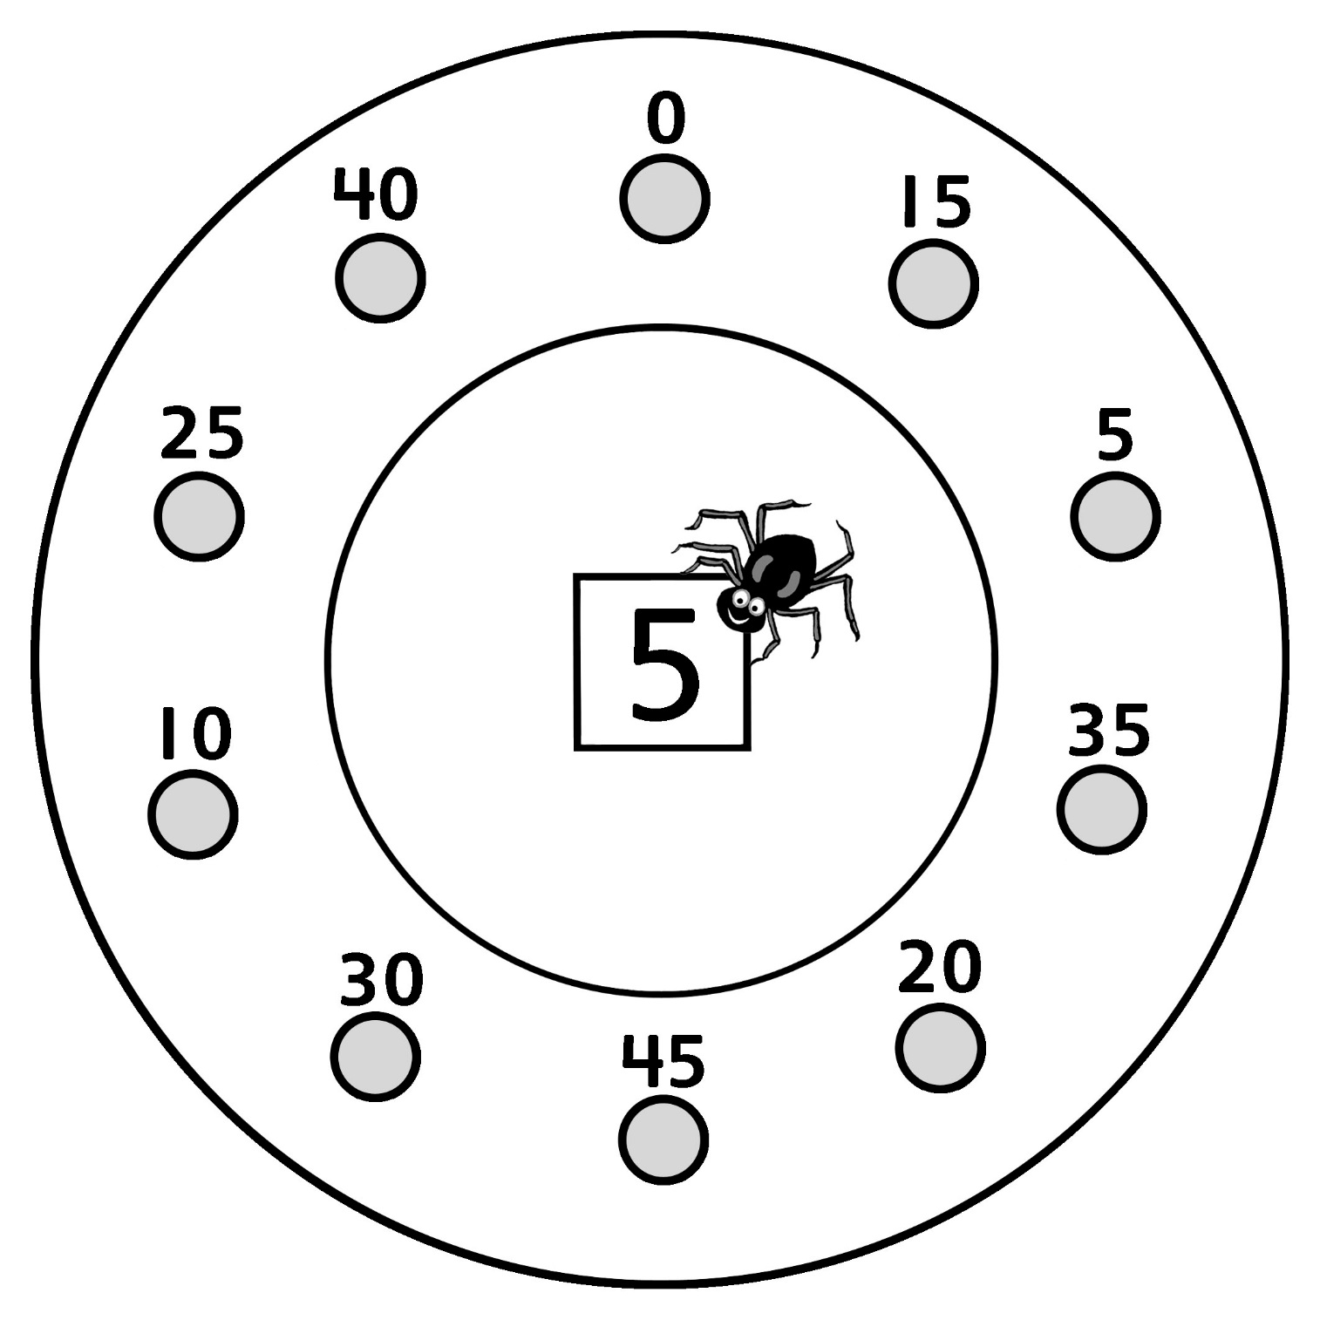

Skip-Counting by 5s Spider Webs
Master 7b

Start at 25. Skip-count by 5s.

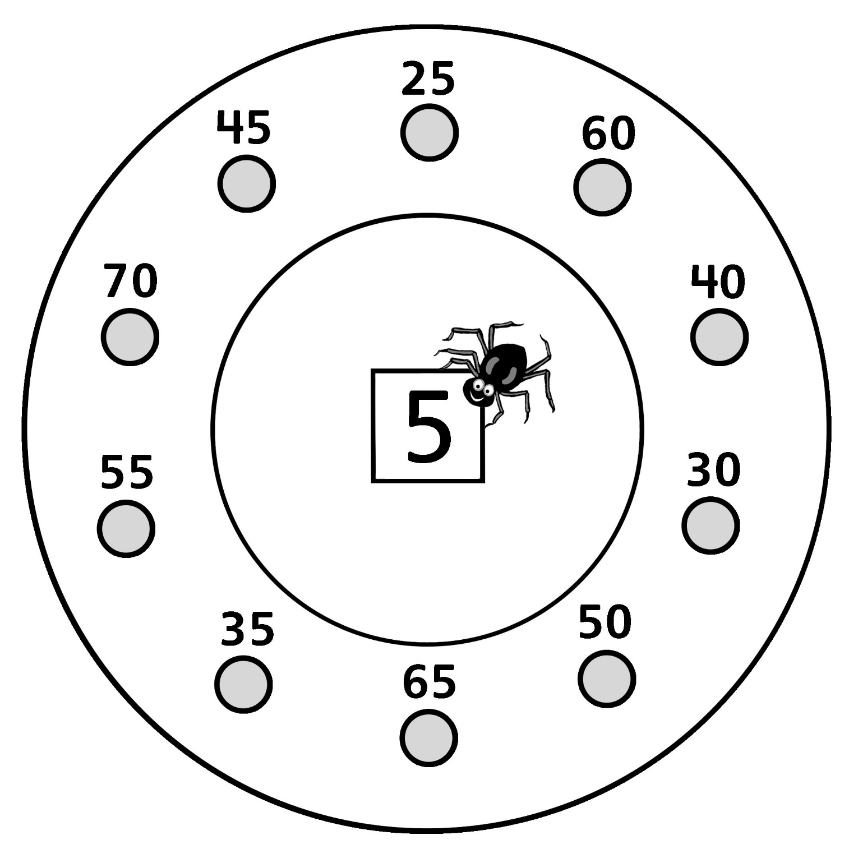

Skip-Counting by 5s Spider Webs
Master 7c

Start at 50. Skip-count by 5s.

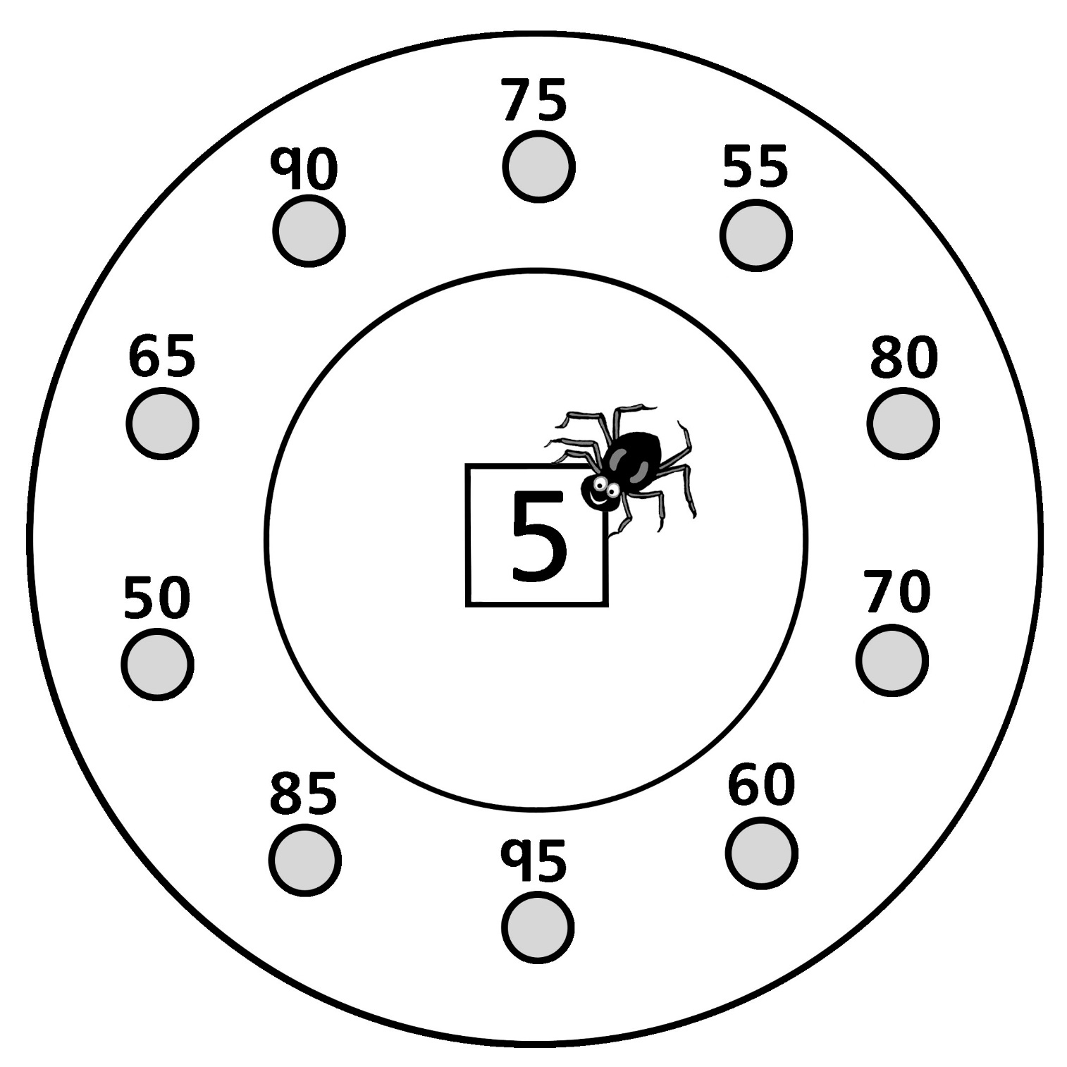

Skip-Counting by 5s Spider Webs
Master 7d

Start at 75. Skip-count by 5s.

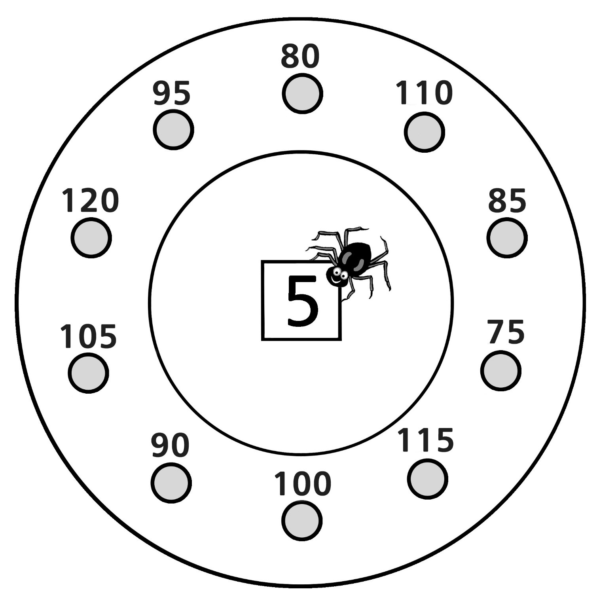

Skip-Counting by 5s Spider Webs
Master 7e

Start at 100. Skip-count by 5s.

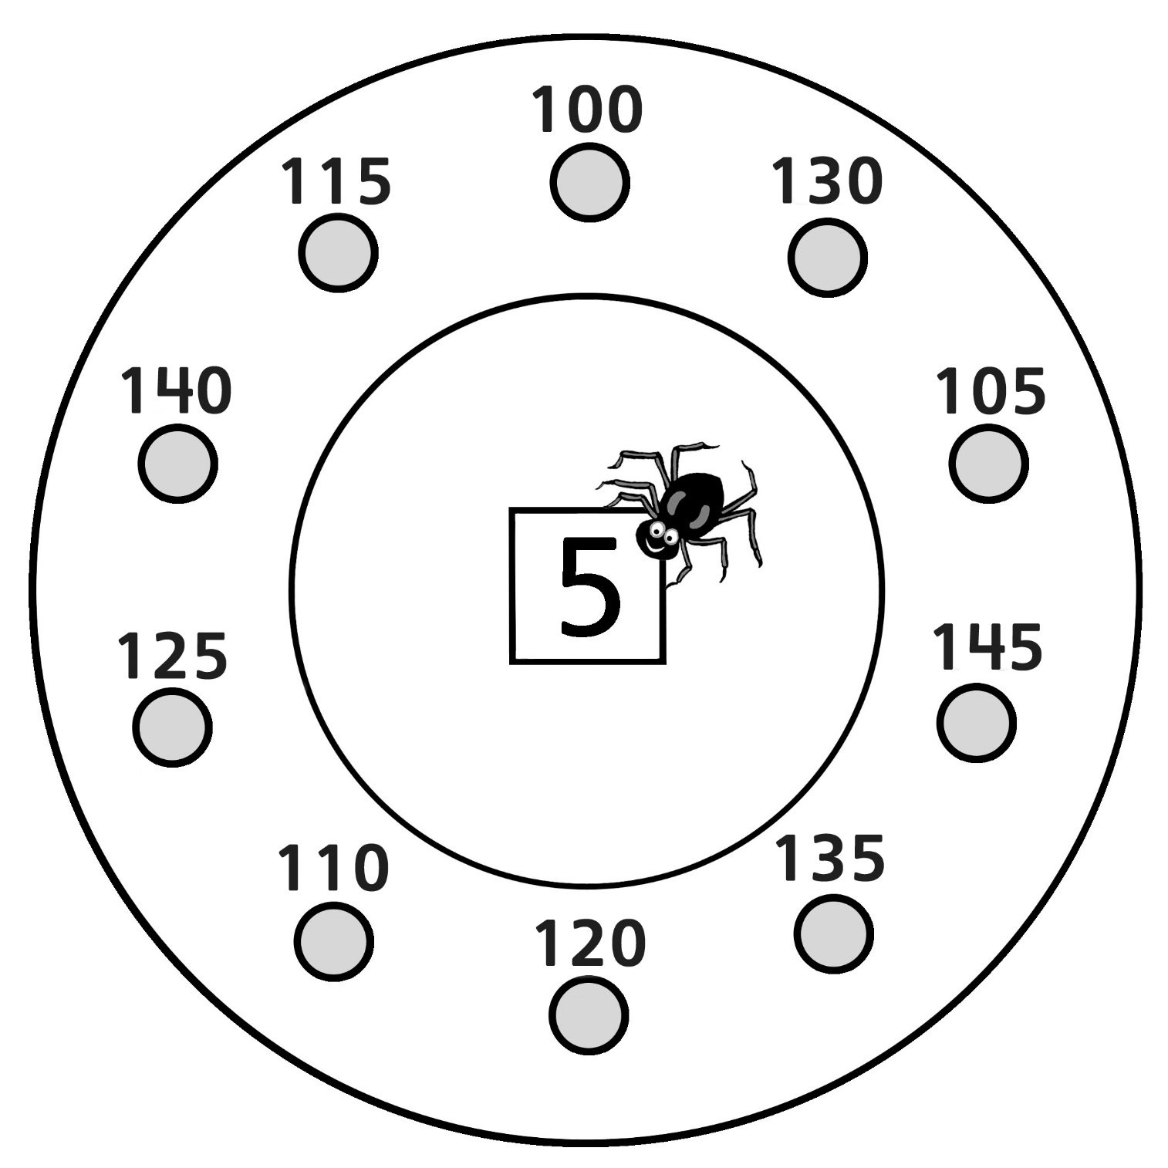
Skip- Counting by 5s Spider Webs
Master 7f

Start at 125. Skip-count by 5s.

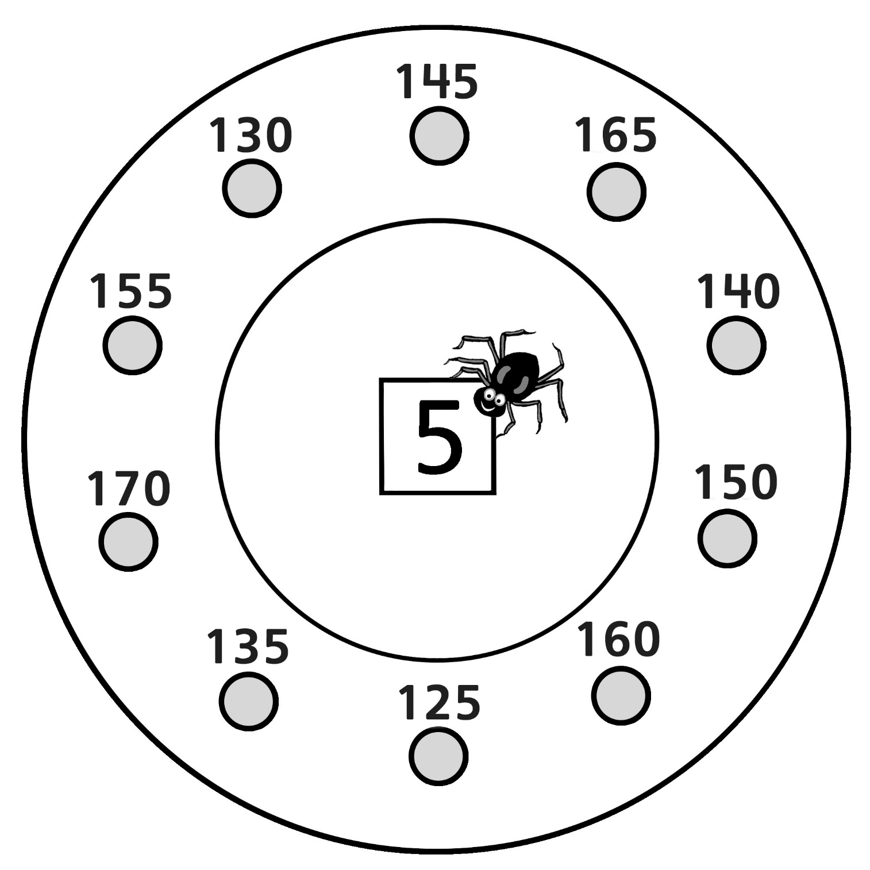

Skip-Counting by 5s Spider Webs
Master 7g

Start at 155. Skip-count by 5s.

