Time Game Cards
Master 29a
Snap your fingers | Clap your hands | Blink | Do  10 jumping jacks
Sing  O Canada | 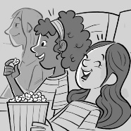  Watch a  movie | 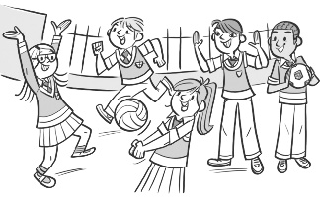  Recess | Spring  Break
Listen to your favourite  song | 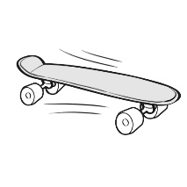  Go skateboarding | 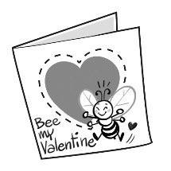  Valentine’s Day | 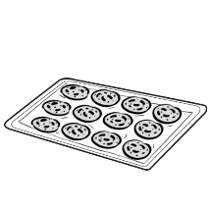  Make  cookies
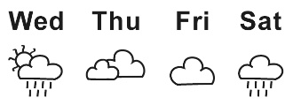  Check the weather | 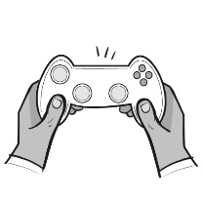  Play a  video game | Lunchtime | The Weekend
Write your name | 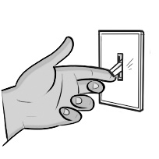  Flip a  light switch | 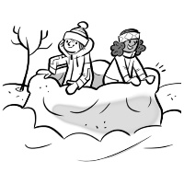  Build a  snow fort | 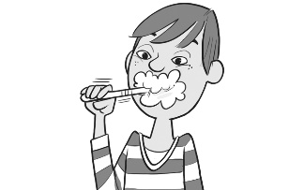  Brush your teeth

Time Game Cards
(for Accommodations)
Master 29b
Snap your fingers | 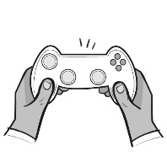  Play a  video game | Blink | Do  10 jumping jacks
Write your name | Watch a  movie | Lunchtime | The Weekend
Check the weather | 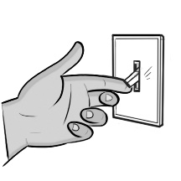  Flip a  light switch | Valentine’s Day | Brush your teeth

Time Game Cards
(for Combined Grades Extension)
Master 29c
10:35 |  |  | 6:20:05
2:55
 |  | 12:20:30

