Measurement Hunt
Master 11a

Length of Eraser  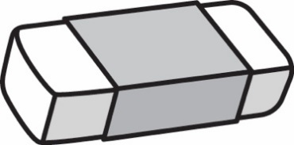  Our estimate is  ____________________________  Our measure is  ____________________________ | Length of Teacher’s Desk  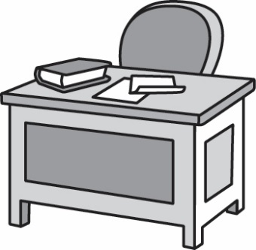  Our estimate is  ____________________________  Our measure is  ____________________________
Length of Pencil  Our estimate is  ____________________________  Our measure is  ____________________________ | Length of Book  Our estimate is  ____________________________  Our measure is  ____________________________

Measurement Hunt
Master 11b

Length of Classroom Floor  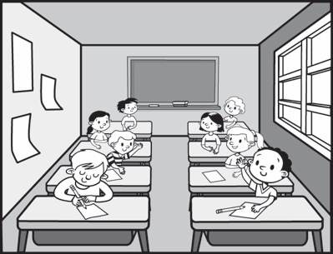  Our estimate is  ____________________________  Our measure is  ____________________________ | Length of Lockers  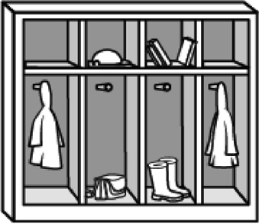  Our estimate is  ____________________________  Our measure is  ____________________________
You Choose!  I chose this object:  Our estimate is  ____________________________  Our measure is  ____________________________ | You Choose!  I chose this object:  Our estimate is  ____________________________  Our measure is  ____________________________

