Estimating and Measuring Length Behaviours/Strategies
- Student estimates objects by length with nonstandard units, but estimates are extreme/  unreasonable.  “About 100 cubes!” | - Student measures objects by length using  multiple copies of a non-standard unit, but  units are not placed end-to-end.  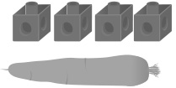 | - Student measures objects by length using  multiple copies of a non-standard unit, but does  not align the base of the first unit with the end  of the object being measured.  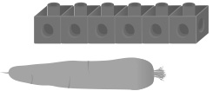
Observations/Documentation
- Student measures objects by length using  multiple copies of a non-standard unit,  measures with cubes, and assumes the same  count for paper clips. | - Student measures objects by length using  multiple copies of a non-standard unit, but  thinks turning an object will affect its length. | - Student successfully estimates and measures objects by length using multiple copies of a non-standard unit and realizes that turning an object does not affect its length.  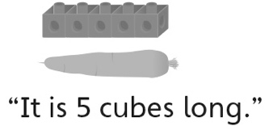
Observations/Documentation

