Measuring Carrots Recording Sheet
Master 2a

Measuring with Centicubes
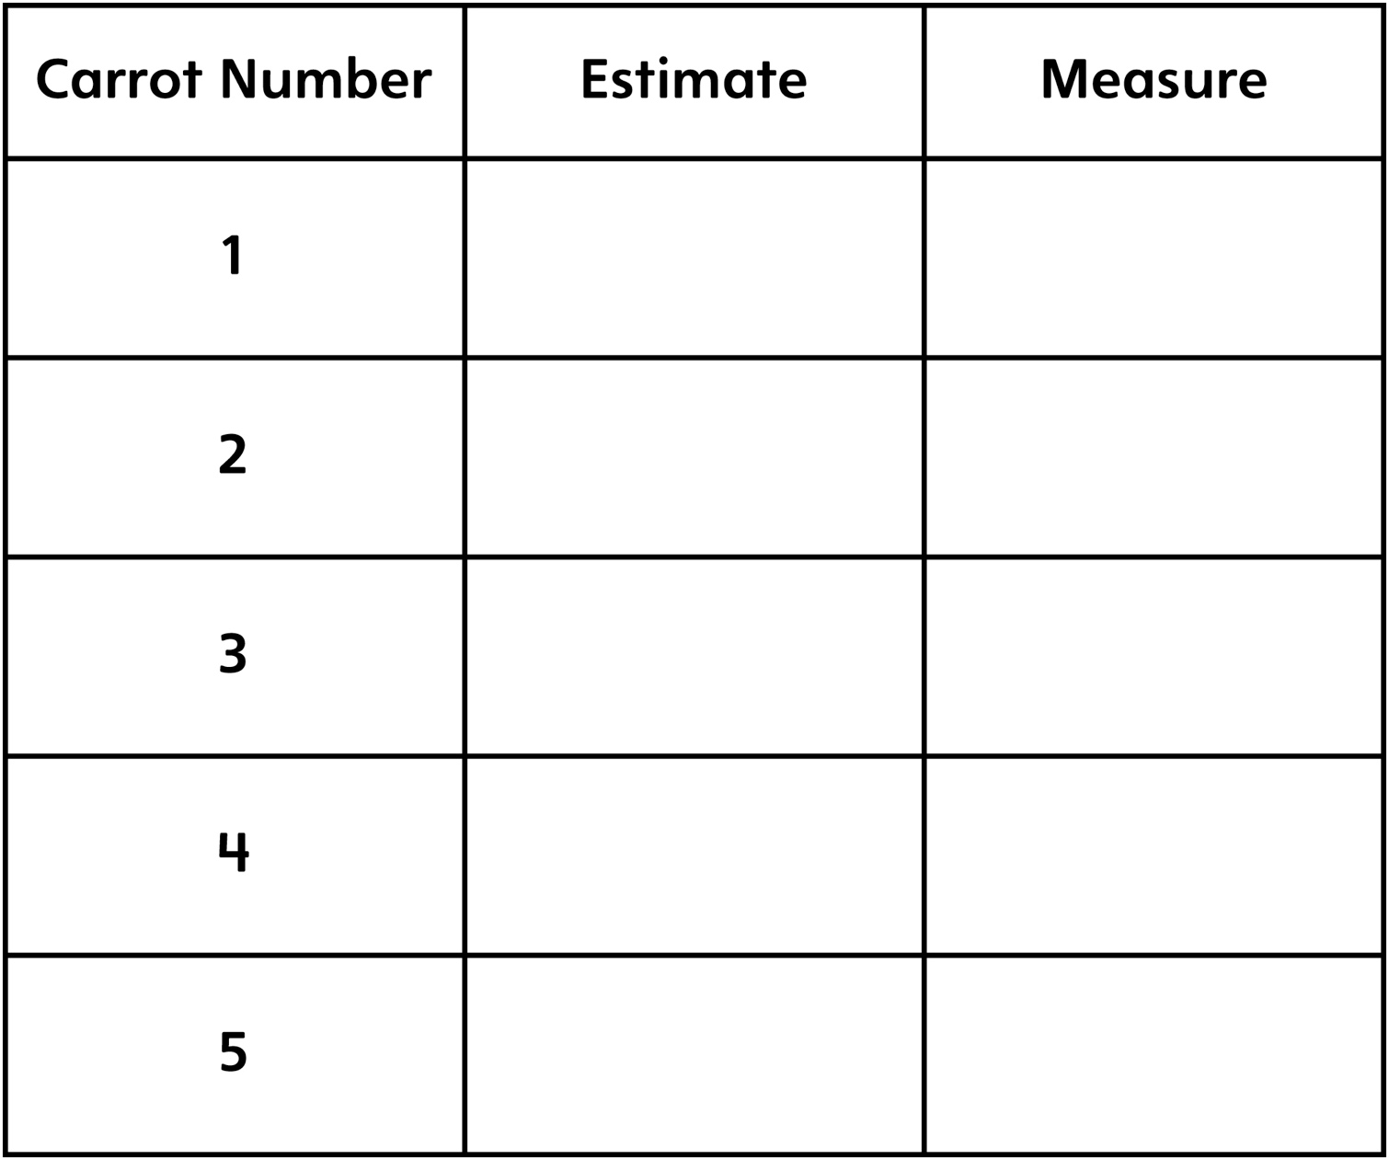

Measuring Carrots Recording Sheet
Master 2b

Measuring with Paper Clips

