Reading and Writing Code Behaviours/Strategies
- Student describes the movement from one  location to another on a grid, but code is not  accurate. Code often contains one extra arrow, as student counts squares instead of steps. |  | - Student describes the movements from one location to the other on a grid and accurately writes code, but struggles to think about how their movements interact with a partner’s movements.  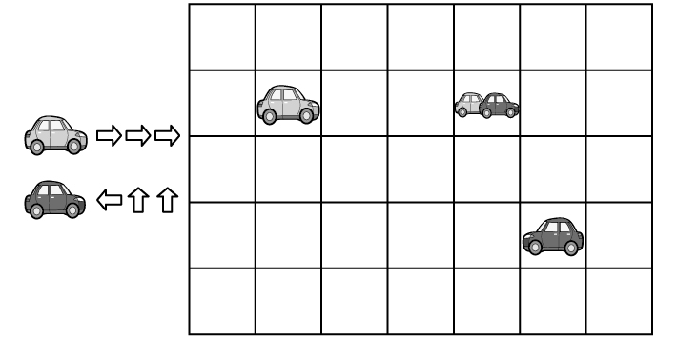 |  | - Student describes the movement from one location to the other on a grid and accurately writes code, but struggles to add “wait” moves t avoid collision.  “Better start over so we don’t crash into each other. You go left, and I’ll go right.”
Observations/Documentation
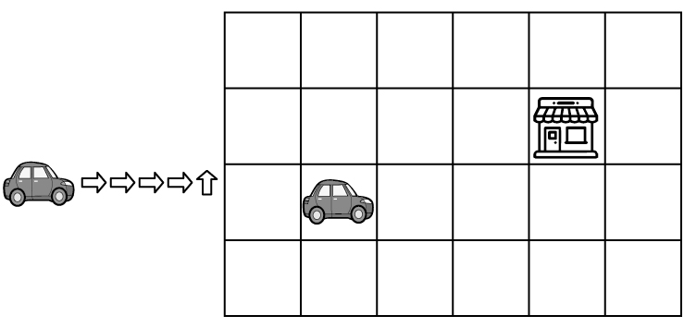
- Student uses guess and test strategies to add movements to their code so that both cars get to the same place at the same time.  “I added 2 steps but still go there before you. Let’s try again.” |  | - Student considers how the cars’ moves related to each other when writing and altering code, but struggles to describe how the changes affect the outcomes.  “Let’s act it out and see what happens.” |  | - Student successfully reads, writes, and alters code and describes how changes to the code affect the outcomes.  “Here, my ‘wait’ move keeps me from crashing into you. Then we don’t drive onto the same spot at the same time until we get to park.”
Observations/Documentation

