Exercise Cards
Master 48a

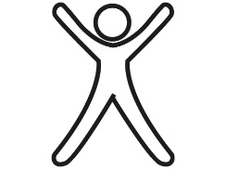Jumping Jacks | 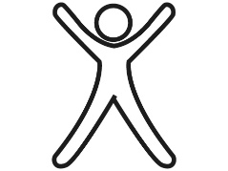Jumping Jacks | Jumping Jacks | Jumping Jacks
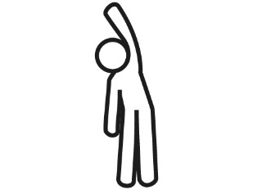Side Bends | Side Bends | Side Bends | Side Bends
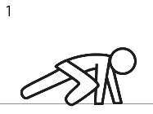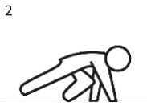  Bear Crawls | Bear Crawls | Bear Crawls | Bear Crawls
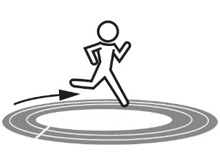Laps | Laps | 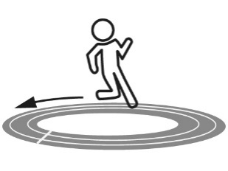Laps | Laps
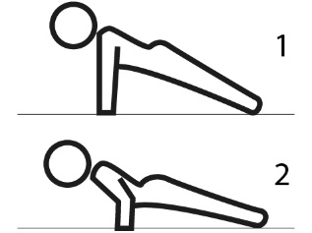Pushups | Pushups | Pushups | Pushups
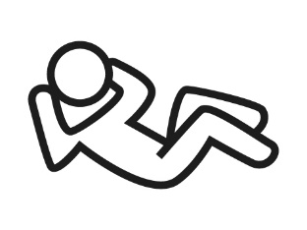Crunches | Crunches | Crunches | Crunches
Exercise Cards
Master 48b

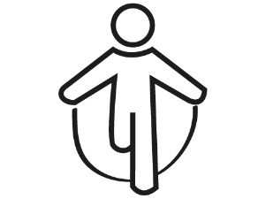  Jump Rope | Jump Rope | Jump Rope | Jump Rope
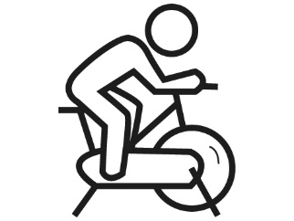  Bike | Bike | Bike | Bike
Weights | Weights | Weights | Weights
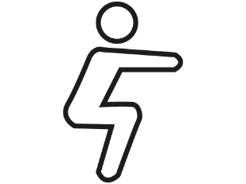Squats | Squats | Squats | Squats
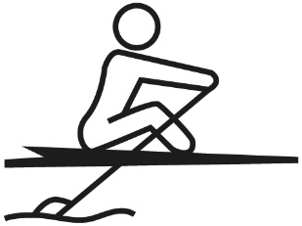Rowing | Rowing | Rowing | Rowing
+0 | +0 | +0 | +0

