Writing Code for Concurrent Events Behaviours/Strategies
- Student describes the movement from one location to another on a grid, but code is not accurate. Code often contains one extra arrow, as student counts squares instead of steps.  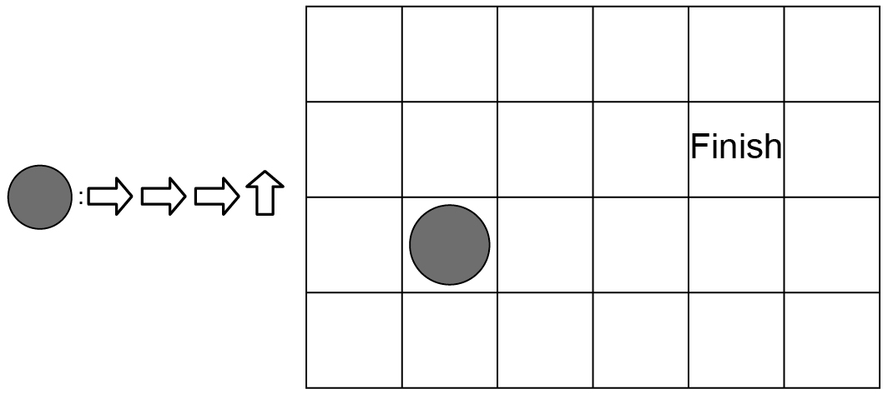 |  | - Student describes the movement from one location to another on a grid and accurately writes code, but struggles to think about how their movements interact with a partner’s movements.  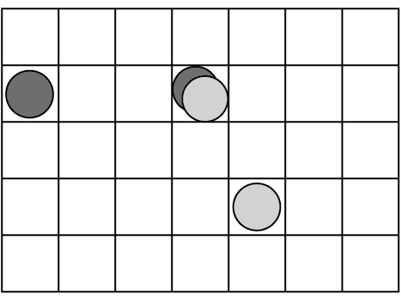  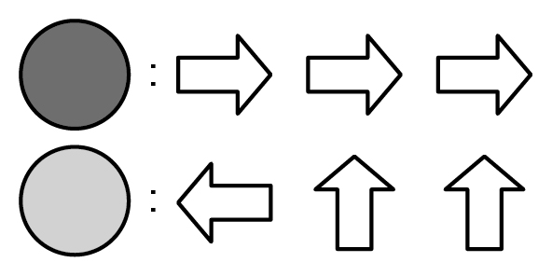 |  | - Student uses guess and test strategies to add movements to their code so that both characters arrive at Finish at the same time.  “I added 2 steps, but I still goth there before you. Let’s try again.”
Observations/Documentation
- Student uses algebraic thinking to add movements to their code so that both characters arrive at Finish at the same time.  “If I go up then down, that adds 2 moves but doesn’t actually move me anywhere.” |  | - Student acts out movements on a grid to see if characters land on the same square at the same time.  “We landed on the same square again. Let’s change our codes and act it out again.” |  | - Student visualizes movements and successfully writes code, ensuring that players do not land on the same square at the same time.  “I start 4 squares to the left of you. Looking at our codes, we never get really close to each other until the Finish.”
Observations/Documentation

