Drawing Maps Behaviours/Strategies
- Student draws outline to make a simple map  based on a familiar setting (classroom), but has trouble placing objects on the map. | - Student makes a simple map based on a familiar setting (classroom) and locates and represents some, but not all, objects on the map. | - Student makes a simple map based on a familiar setting (classroom) and places most objects on the map, but struggles with accuracy or relative sizes.  “I don’t know how big to draw the bookcase.”
Observations/Documentation
- Student makes a simple map based on a familiar setting (classroom) and places objects accurately, but omits important features in favour of unimportant or personal features.  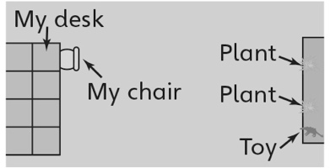 | - Student makes a simple map based on a familiar setting (classroom), but omits labels or places labels incorrectly.  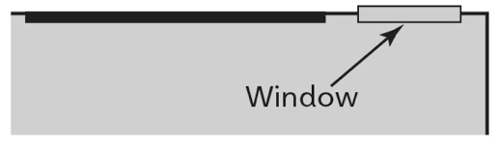 | - Student successfully makes a simple map based on a familiar setting (classroom).
Observations/Documentation

