**Maps with Grid**

**Master 33a**

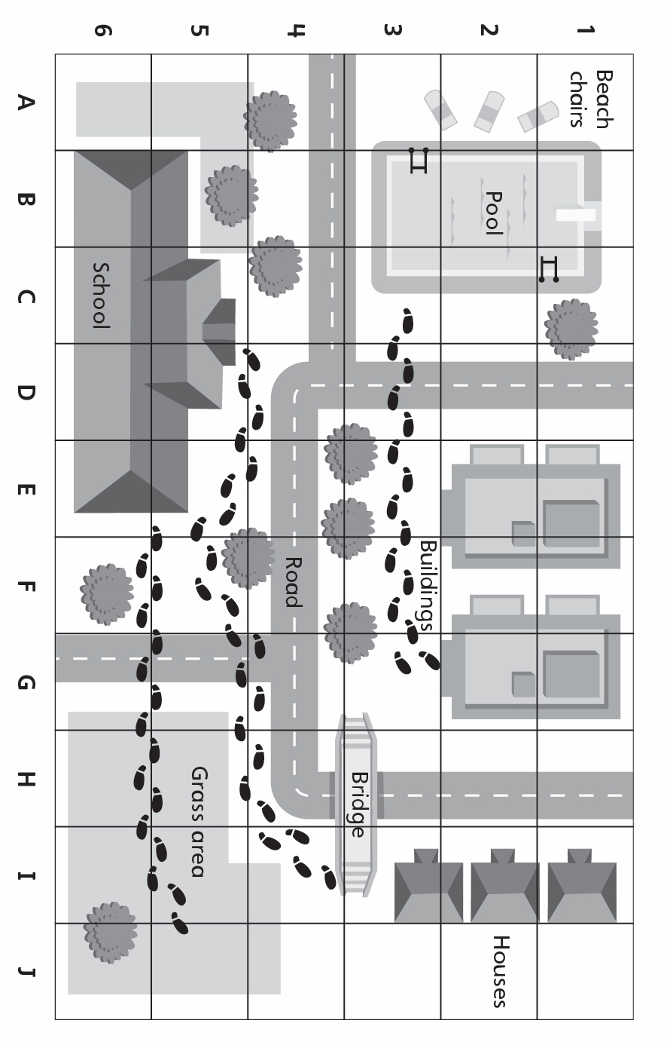

**Maps with Grid**

**Master 33b**

