Geometric Relationship Tasks Behaviours/Strategies
- Student uses blocks or pieces, but  struggles to construct new  2-D shapes as a composite of other 2-D shapes. |  | - Student constructs a composite  picture with 2-D shapes, but each  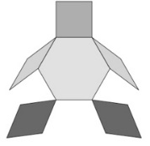  shape represents a part of an object (shapes are not combined). |  | - Student covers a picture outline with shapes, but picture has gaps or overlaps.  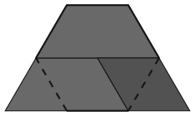
Observations/Documentation
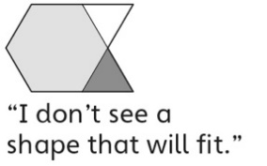  - Student covers a picture outline with shapes, but always tries to place matching blocks in the same relative position. |  | - Student constructs a new 2-D shape as a composite of other shapes and covers outlines, but thinks only one way is possible. |  | - Student successfully constructs 2-D shapes and composite pictures, and covers outlines in more than one way.

