Identifying Congruent Lengths, Angles, and 2-D Shapes Behaviours/Strategies
- Student recognizes and names familiar 2-D shapes, but is unable to match congruent shapes.  “This one’s a triangle. That one’s a square.” |  | - Student identifies how 2-D shapes are alike and how they are different, but has difficulty determining if the shapes are congruent.  “The triangle has 3 sides. The square has 4 sides. Their sides are the same length. I don’t know if they’re congruent.” |  | - Student physically matches congruent 2-D shapes by rotating one shape and placing it on top of the other, but cannot explain why the shapes are congruent.  “They’re the same. They’re congruent.”  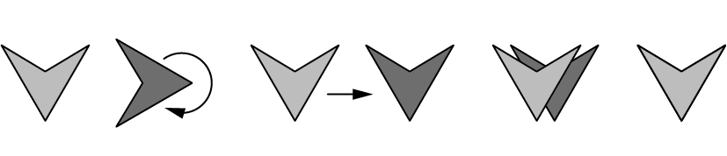
Observations/Documentation
- Student physically matches congruent 2-D shapes, but has difficulty mentally matching congruent shapes.  “I can’t tell if they’re congruent just by looking.”  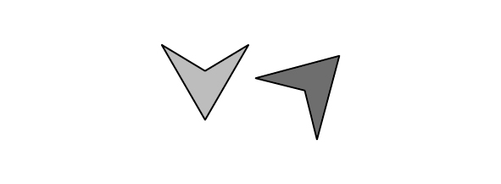 |  | - Student mentally matches congruent 2-d shapes, but doesn’t identify or describe congruent side lengths and angles.  “I just know they’re congruent.” |  | - Student uses mental and physical matching to determine if 2-D shapes are congruent and to identify congruent side lengths and angles.  “I visualized the angles and sides all matching, but when I physically matched them, I could see that all angles matched, but only 2 of the sides matched. One is a square and the other a rectangle. They are not congruent.”
Observations/Documentation

