**Spinner Templates (for *Extension*)**

**Master 36a**



**Spinner Templates (for *Extension*)**

**Master 36b**

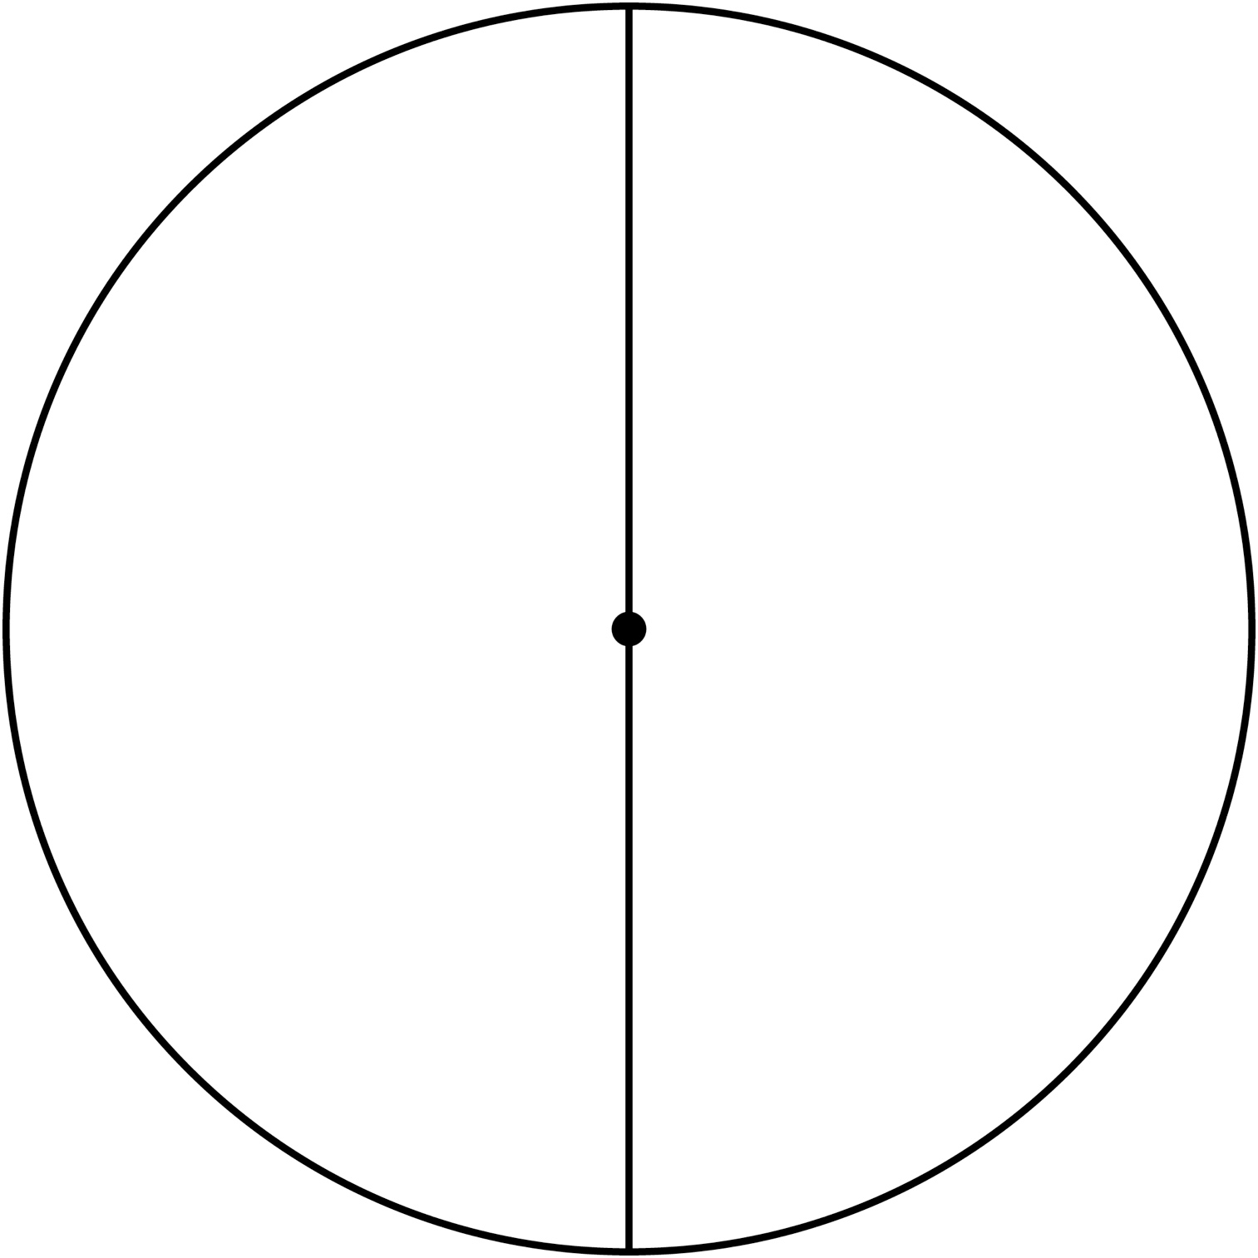

**Spinner Templates (for *Extension*)**

**Master 36c**

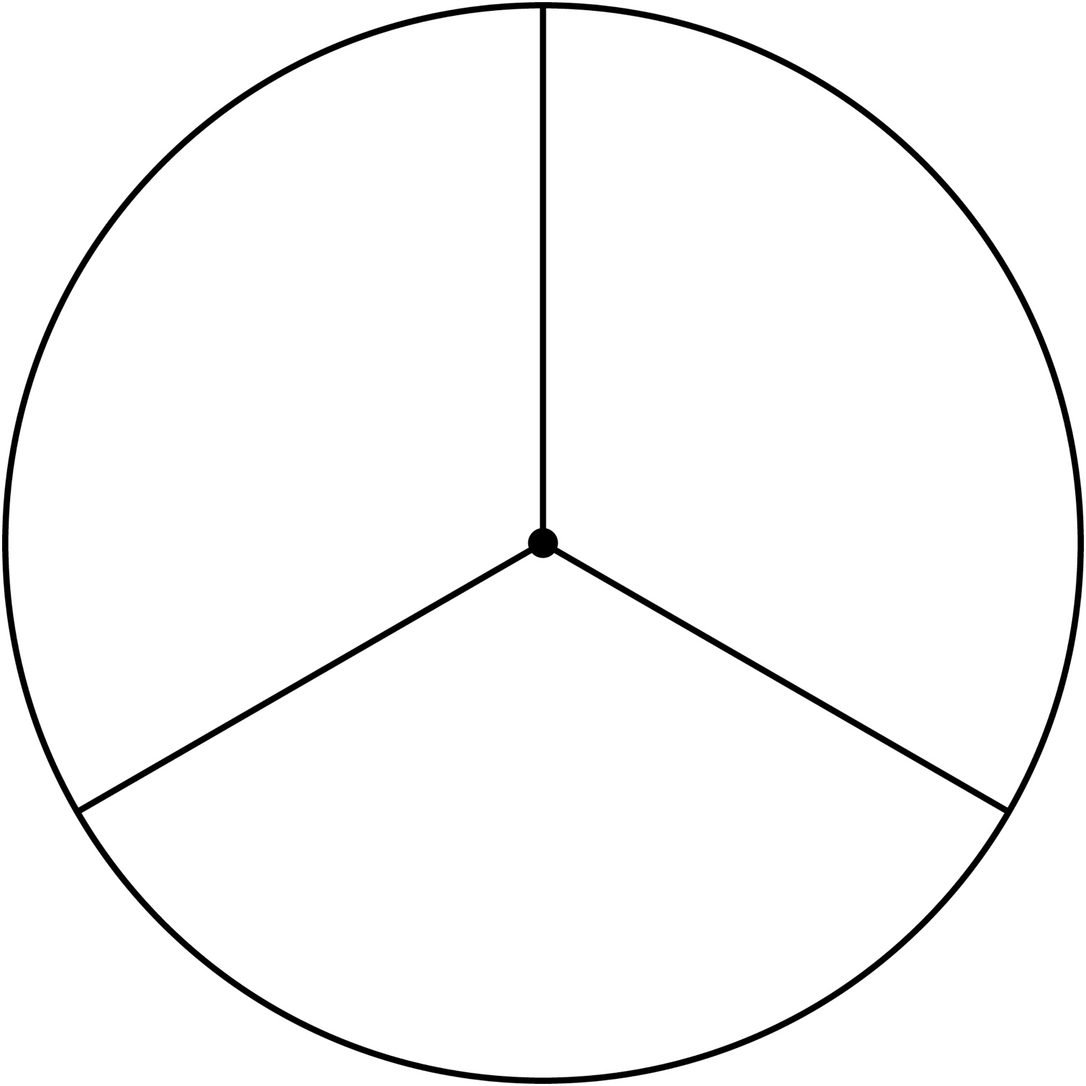

**Spinner Templates (for *Extension*)**

**Master 36d**

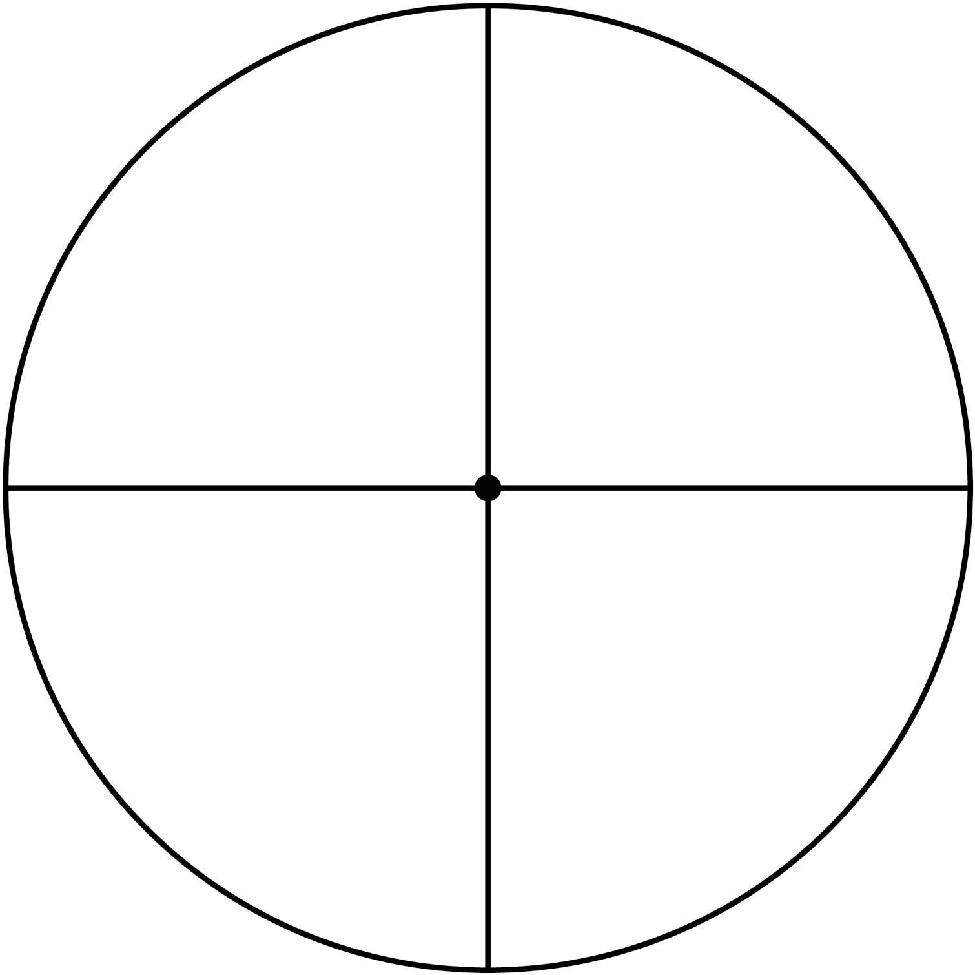

**Spinner Templates (for *Extension*)**

**Master 36e**

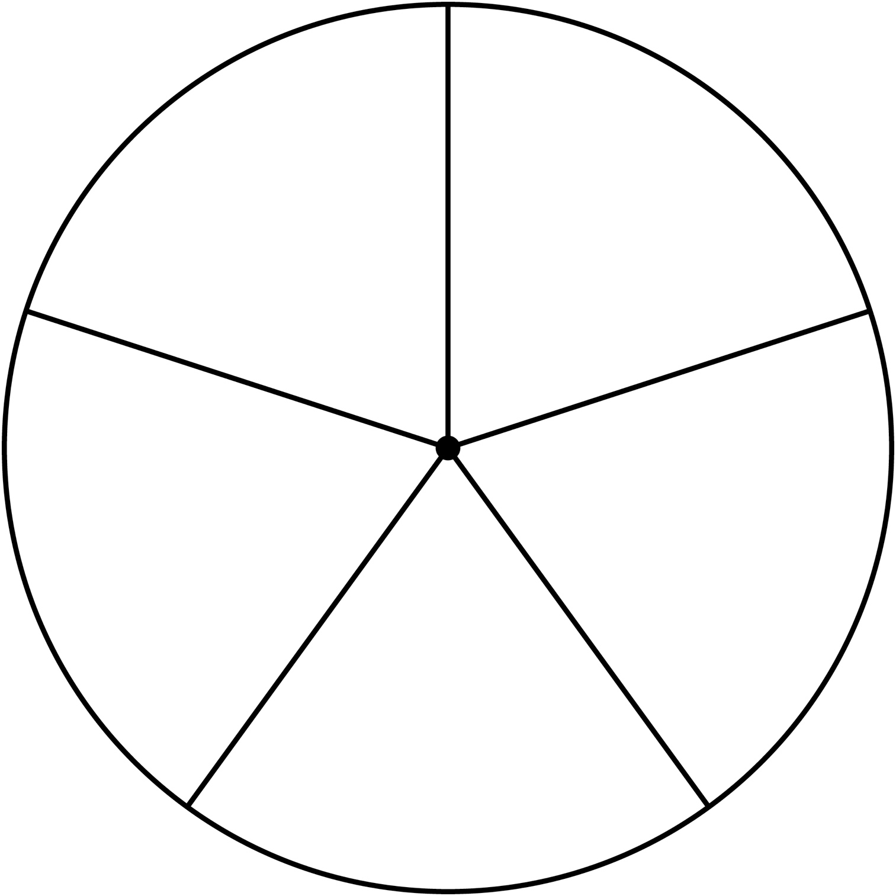

**Spinner Templates (for *Extension*)**

**Master 36f**

