Data Graphs (Accommodations)
Master 23a

Number of Siblings

X X
X X
X X X X X X
______________________________________________
0 1 2 3 4 5

Source: Gr. 2 Class

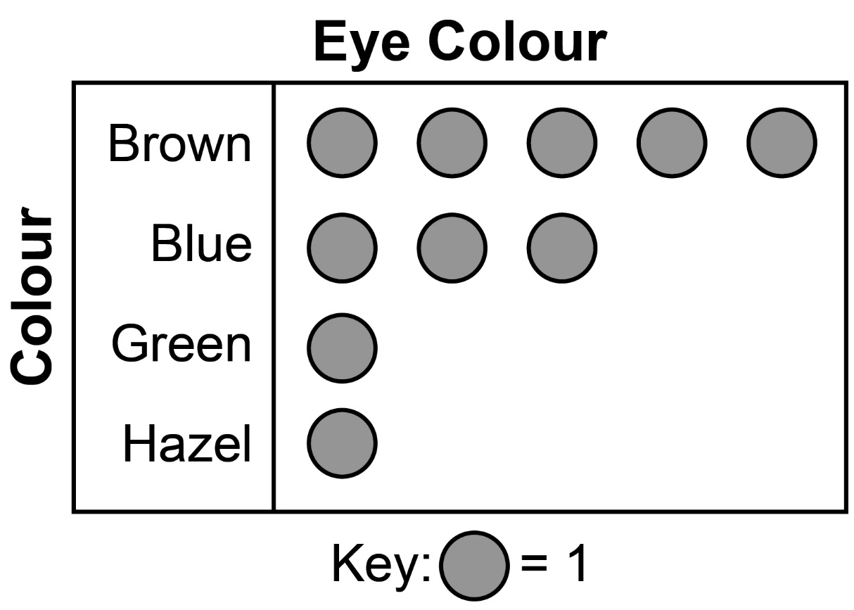
Source: Gr. 2 Class
Data Graphs (Accommodations)
Master 23b

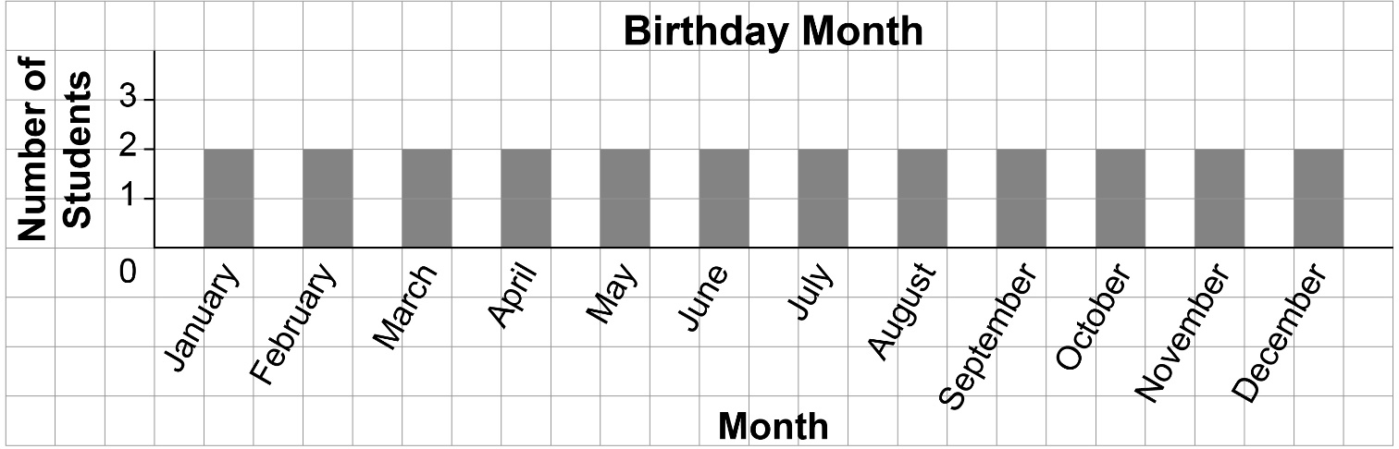
Source: Gr. 2 Class

Age of Students

X
X X
X X
X X
X X X
_________________________
6 7 8
Source: Gr. 2 Class

