Expressing Equality and Inequality Behaviours/Strategies
- Student chooses a number, but struggles to  decompose number into two parts and model it with cubes. | - Student models equality with cubes, but  struggles to record different expressions of  the same quantity as equalities (cannot write  number sentence).  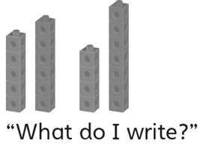 | - Student models equality, but does not consider  zero, or thinks the same cubes in the opposite  order is not an equality.  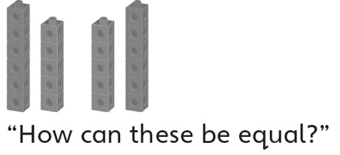
Observations/Documentation
- Student models equality, but struggles to model inequality. | - Student models inequality, but struggles to  use the greater than or less than sign when comparing expressions.  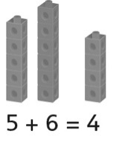 | - Student models equality and inequality, records  different expressions of the same quantity as  equalities, and understands and uses the equal  (=) and greater than (>) or less than (<) signs when comparing expressions.  15 + 6 = 14 + 7  15 + 6 ≠ 14 + 5
Observations/Documentation

