Greater Than, Less Than, or Equal? Cards
Master 32a

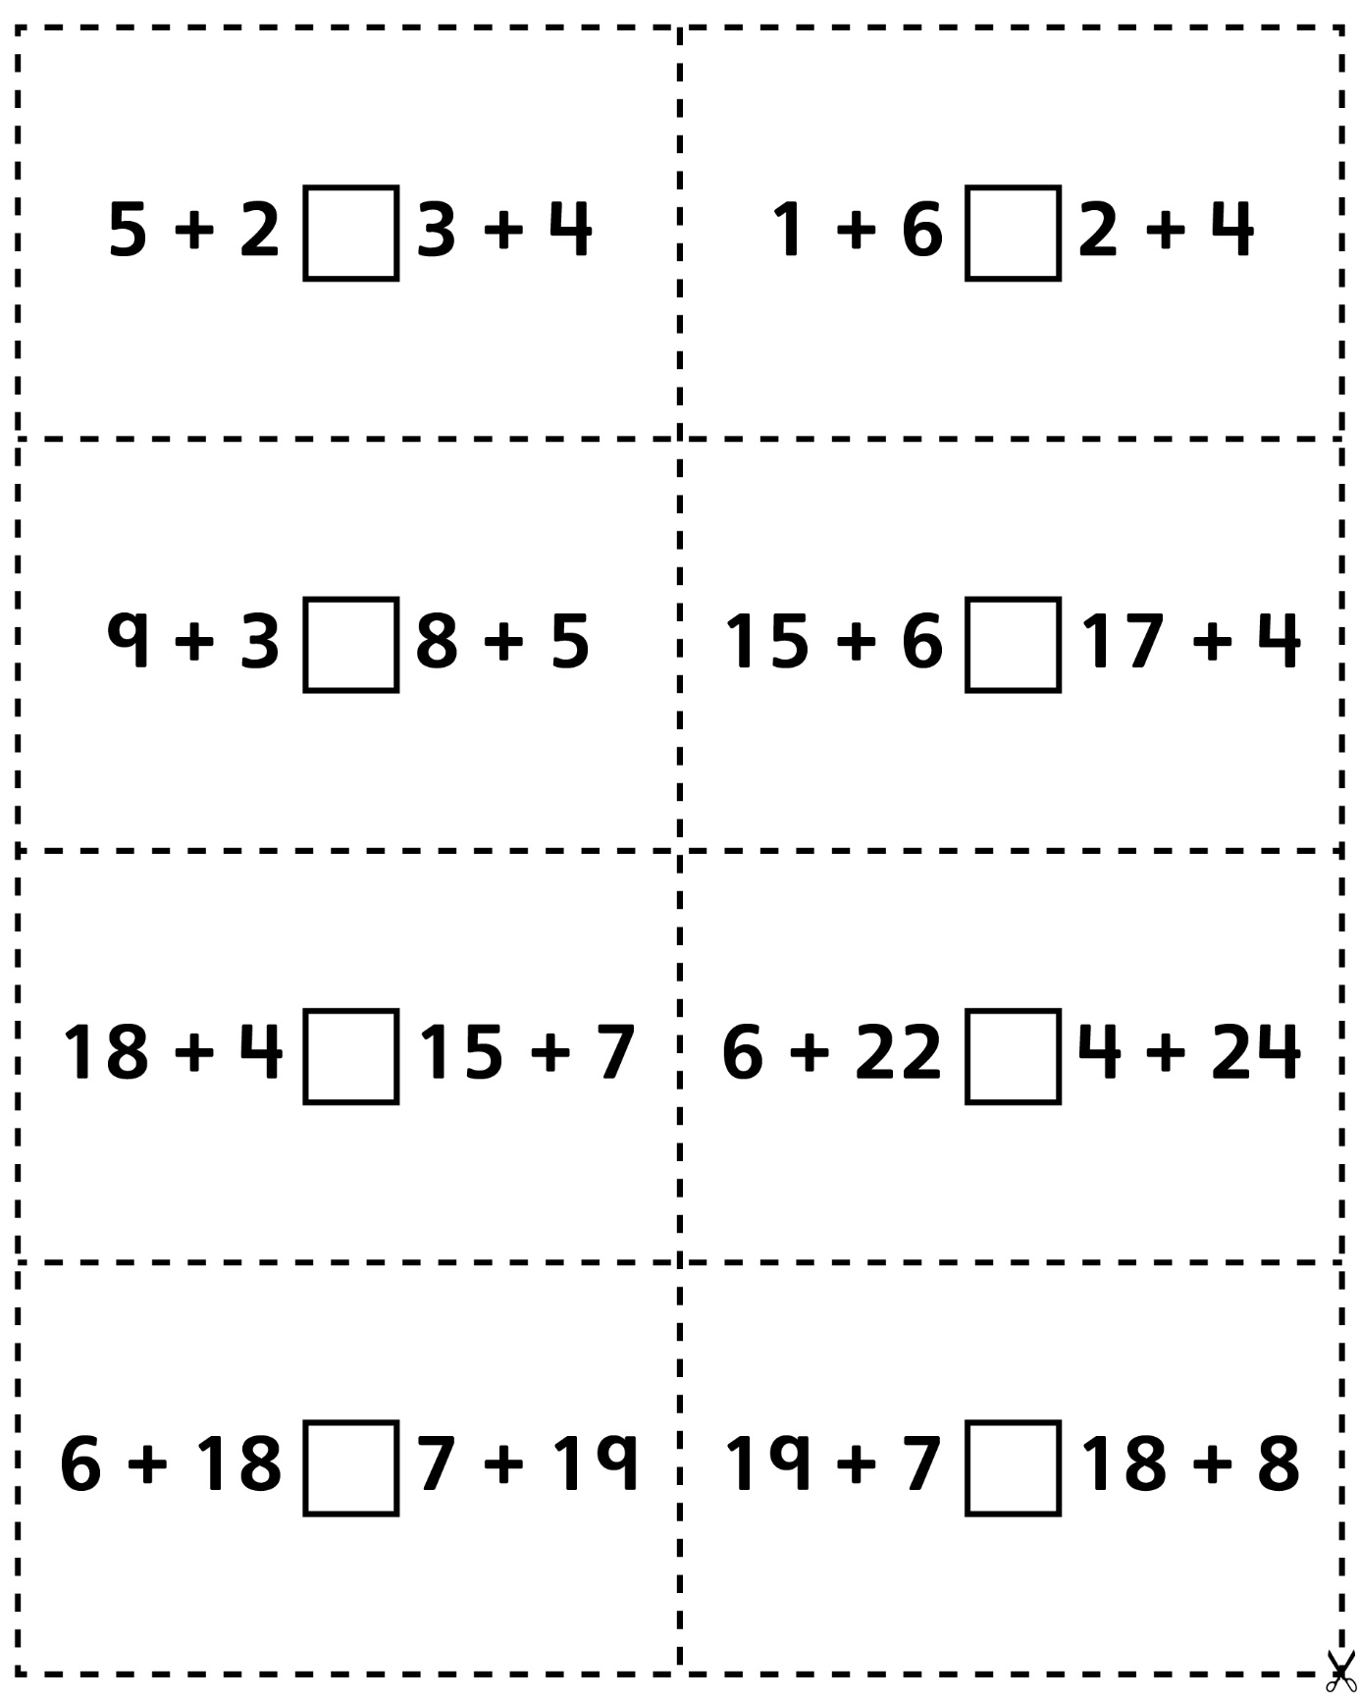
Greater Than, Less Than, or Equal?Cards
(for Accommodations)
Master 32b

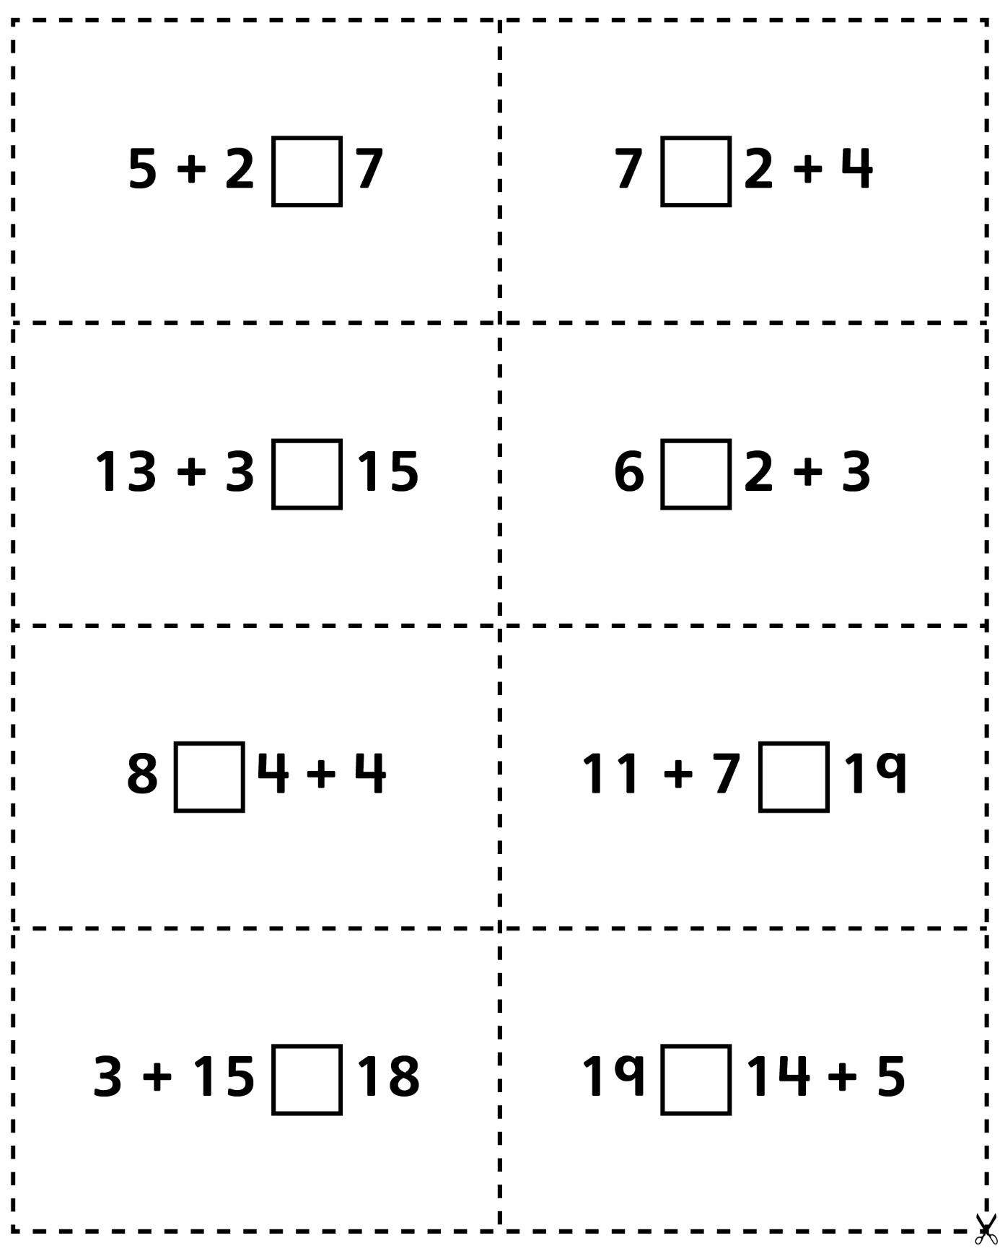
Greater Than, Less Than, or Equal? Cards
(for Extension)
Master 32c

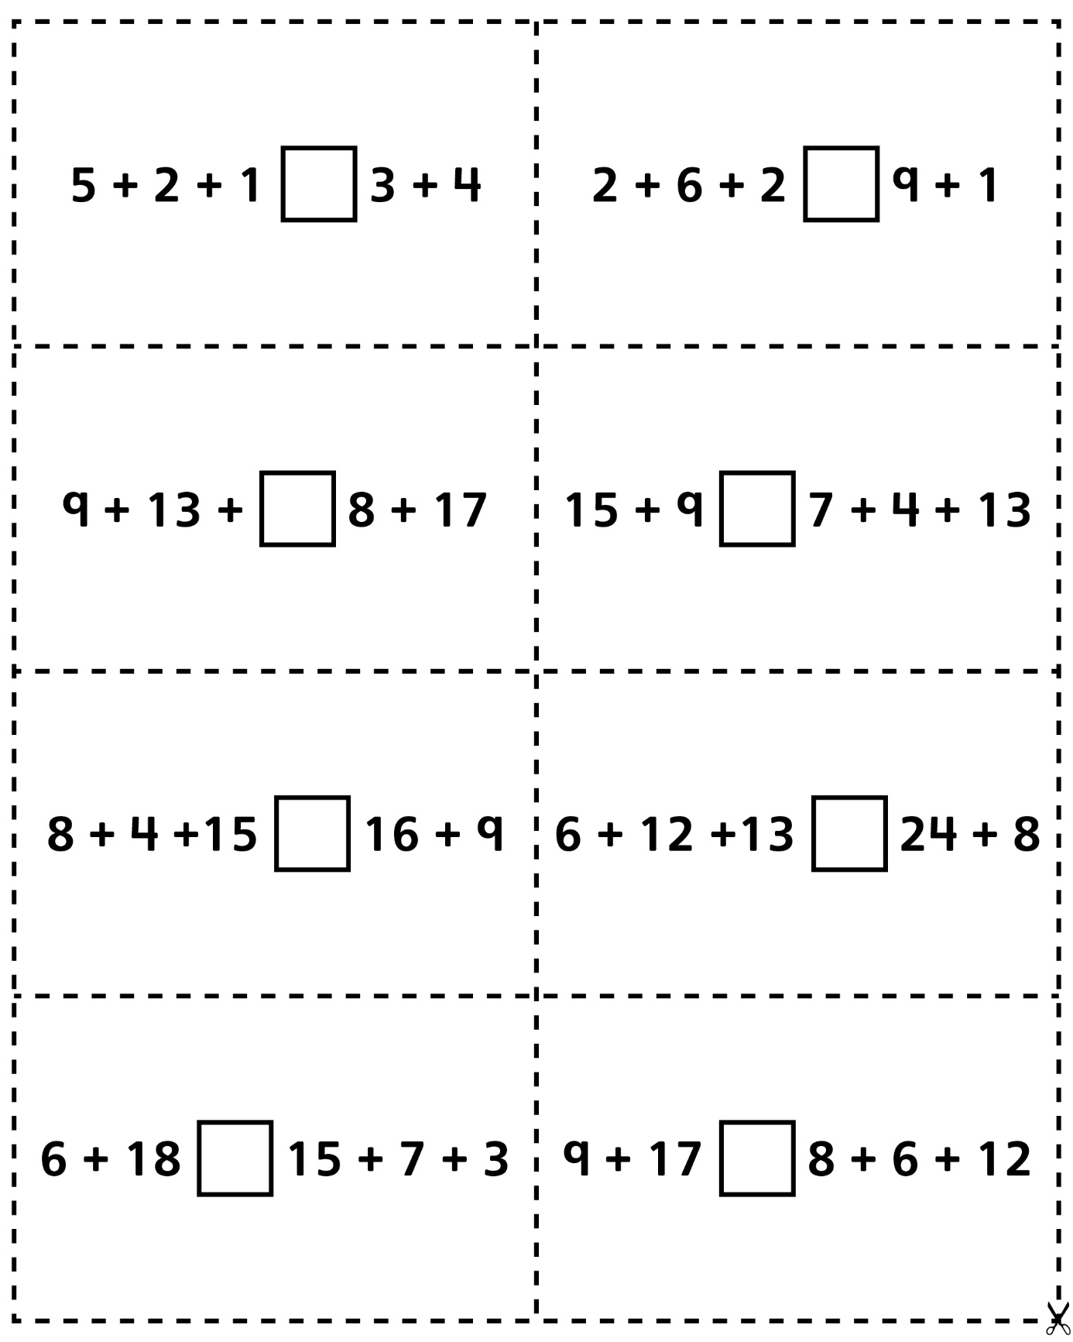
Greater Than, Less Than, or Equal?Cards
(for Combined Grades Extension)
Master 32d

