Finding Errors and Missing Terms Behaviours/Strategies
- Student takes linking cubes, but struggles to  create an increasing pattern. | - Student makes an increasing pattern with  missing terms or errors, but cannot identify  the pattern rule of partner’s pattern to predict missing term(s) and correct errors.  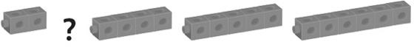 | - Student explains the rule, but has difficulty  predicting missing term(s) in an increasing pattern.  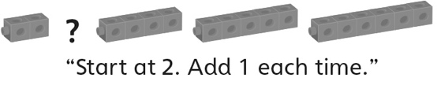
Observations/Documentation
- Student explains the rule, but has difficulty  correcting errors in an increasing pattern.  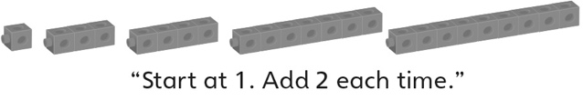 | - Student predicts missing term(s) and corrects  errors in increasing patterns, but struggles to  explain how an error or missing term was found. | - Student successfully predicts missing term(s)  and corrects errors in increasing patterns and  justifies thinking.
Observations/Documentation

