Creating Increasing Patterns Behaviours/Strategies
- Student chooses materials, but struggles to  create an increasing pattern and randomly  groups items or creates a repeating pattern.  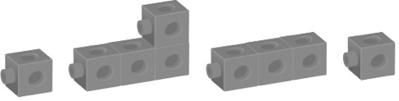 | - Student chooses materials and attempts to  create an increasing pattern, but does not add  the same number of items each time.  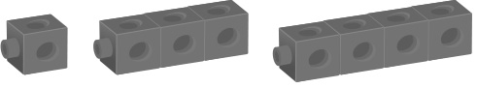 | - Student creates an increasing pattern, but items  are not added in the same way each time.  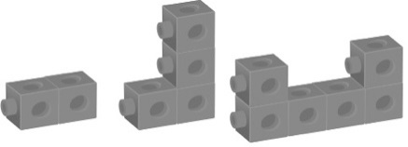
Observations/Documentation
- Student creates an increasing pattern, but  struggles to write the pattern rule.  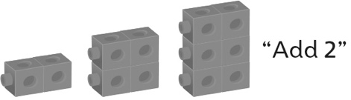 | - Student creates an increasing pattern, but is not sure if partner’s pattern rule is correct.  “I’m not sure if it’s right.” | - Student successfully identifies and creates an  increasing pattern and explains the pattern rule.
Observations/Documentation

