Reproducing Increasing Patterns in Different Ways Behaviours/Strategies
- Student chooses an increasing pattern, but  struggles to reproduce it in different ways and  randomly performs actions (gives no thought to number of actions).  Pattern: 1, 3, 5, 7  “Clap-clap-clap-clap-clap-clap-clap” | - Student reproduces the same increasing pattern in some ways, but is unable to represent the pattern with numbers or write the pattern rule. | - Student reproduces the same increasing pattern in different ways, but does not have the correct number of items in some of the terms.  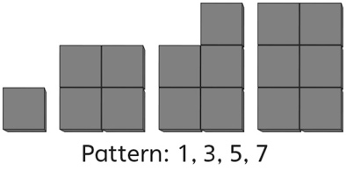
Observations/Documentation
- Student reproduces the same increasing pattern in different ways, matching the number of items in each term to the number pattern.  1, 3, 5, 7  “All the numbers match.” | - Student successfully reproduces the same  increasing pattern in different ways, but cannot prove that all ways are the same.  “I just know they all show the same pattern.” | - Student successfully reproduces the same  increasing pattern in different ways.
Observations/Documentation

